A signal detection theoretic method for estimating metacognitive sensitivity from confidence ratings
Brian Maniscalco and Hakwan Lau
Columbia University

Author note

Brian Maniscalco, Department of Psychology, Columbia University; Hakwan Lau, Department of Psychology, Columbia University.
This work is supported by internal funding from Columbia University (to HL). We thank Dobromir Rahnev and Steve Fleming for their helpful comments on the manuscript.
Correspondence concerning this article should be addressed to Brian Maniscalco, Department of Psychology, Columbia University, 1190 Amsterdam Ave., MC 5501, New York, NY 10027. Phone: (212) 851-2787 E-mail: brian@psych.columbia.edu
Suggested running head: Signal detection theory analysis of metacognition
Abstract
How should we measure metacognitive ("type 2") sensitivity, i.e. the efficacy with which an observer's confidence ratings discriminate between his own correct and incorrect stimulus judgments? We provide demonstrations grounded in signal detection theory (SDT) showing that many previously proposed measures of type 2 sensitivity are confounded with type 2 response bias as well as sensitivity and bias in the “type 1” task of stimulus classification. Extending the analysis of Galvin et al. (2003), we propose a principled and flexible SDT approach for quantifying type 2 sensitivity without the confounding influences of type 1 task performance and type 2 response bias. This new approach allows us to precisely characterize the functional sensitivity of metacognitive mechanisms themselves, regardless of the observer’s decision strategies or ability to perform the type 1 task. We discuss computational, theoretical, and conceptual issues regarding this approach to characterizing type 2 sensitivity.
Keywords: metacognition, confidence, signal detection theory, type 2 sensitivity

In various psychological tasks, one measure of interest may be how well an observer's confidence ratings predict judgment accuracy. For instance, suppose that an observer performs a perceptual discrimination task, and on every trial provides a judgment about how confident he is that his perceptual discrimination is correct. We may then ask: to what extent are the observer's confidence judgments diagnostic of actual response accuracy? In the literature, the task of discriminating between one's own correct and incorrect responses with confidence judgments has been called the "type 2 task" (Clarke, Birdsall, & Tanner, 1959; Galvin, Podd, Drga, & Whitmore, 2003; Higham, Perfect, & Bruno, 2009), as opposed to the "type 1 task" of discriminating between stimulus alternatives.
Although many researchers have expressed interest in characterizing type 2 sensitivity, i.e. the efficacy with which confidence judgments discriminate between correct and incorrect stimulus judgments, there is as yet no widespread agreement on how best to do so. Several considerations make the prospect somewhat challenging. First, the measure should be uncontaminated by response bias. That is, the measure of type 2 sensitivity should not be affected by an observer’s subjective standards for what levels of confidence deserve to be labeled “high confidence” rather than “low confidence.” The classical signal detection theory (SDT) solution to the problem of response bias in the type 1 task is to model how different stimulus classes generate distinct distributions of evidence along some internal decision axis; the distance between the distributions (with respect to their standard deviations) provides a bias-free measure of type 1 sensitivity (Macmillan & Creelman, 2005; Fig 1A). The analogous strategy for the type 2 task would be to model how correct and incorrect stimulus judgments are associated with distributions of evidence along some internal type 2 decision axis, and then to quantitatively characterize their overlap. However, attempts to do so (Kunimoto, Miller, & Pashler, 2001) have met with theoretical (Galvin et al., 2003) and empirical (Evans & Azzopardi, 2007) difficulties.
Galvin et al. (2003) showed that, in fact, specifying sensitivity and response bias in the type 1 SDT model entails what form the type 2 distributions should take, assuming all information available for the type 1 task is harnessed for the type 2 task. However, deriving type 2 distributions from the type 1 model is complicated and mathematically intensive even with strong simplifying assumptions that are unlikely to hold for most data sets (Galvin et al., 2003, Appendix A). Thus, characterizing type 2 sensitivity in this way loses much of the appealing mathematical and conceptual simplicity and intuitiveness of the type 1 SDT model.
Additionally, Galvin et al.’s work implies that type 2 sensitivity can be strongly affected by type 1 sensitivity and response bias. The implication is that, in general, observers who perform better at a stimulus classification task (have higher d’) should also be better at distinguishing between their own correct and incorrect stimulus judgments with confidence ratings. The degree to which an observer exhibits response bias in the type 1 task also affects expected performance in the type 2 task. This raises a further issue: if we wish our measure of type 2 sensitivity to specifically isolate the efficiency of confidence rating mechanisms in and of themselves, we must treat type 1 task performance as a potential confound.
It is useful here to distinguish between absolute and relative measures of type 2 sensitivity. We define an absolute measure of type 2 sensitivity as one that quantifies an observer’s overall ability to distinguish correct judgments from incorrect ones, regardless of type 1 task performance. A relative measure of type 2 sensitivity is one that treats type 1 task performance as a confound and corrects for it, so that variation in this measure can only be attributed to variation in the efficacy of confidence rating mechanisms.
The different measures can be used for different purposes. If one wanted to know how much an observer’s confidence judgment can be trusted to predict the accuracy of his responses, one would refer to an absolute measure of type 2 sensitivity, such as area under the type 2 ROC curve (we explain this and related measures below). But on such an analysis, it remains unclear to what extent the exhibited level of type 2 sensitivity depends on type 1 and type 2 performance. For instance, one observer may be very poor at discerning correct from incorrect judgments due to poor metacognitive faculties, while another may be poor at discerning correct from incorrect judgments merely because he performed the type 1 task itself poorly. If one wanted to know how well the observer’s metacognitive faculties in and of themselves were functioning by isolating the specific contribution of type 2 mechanisms to type 2 performance, one would refer to a relative measure of type 2 sensitivity.
To summarize, here is a list of desirable properties for the ideal measure of type 2 sensitivity: It should be independent of biases in confidence reporting; it should be easily expressed in both absolute and relative terms; and it should be relatively simple, intuitive, and tractable to understand and use. In the following we examine previously used measures of type 2 sensitivity and find them lacking in some or all of these desirable properties. We then propose a new conceptual and methodological approach that satisfies our criteria for providing a good measure of type 2 sensitivity.
Previously used measures of type 2 sensitivity
For tasks in which an observer is presented with instances of two stimulus classes S1 and S2 over many trials and must classify each stimulus as belonging to S1 or S2, type 1 task performance is often analyzed in terms of hit rate and false alarm rate:
type 1 hit rate = p(“S2” response | S2 stimulus presented)
type 1 false alarm rate = p(“S2” response | S1 stimulus presented)
In the type 2 task, the observer must discriminate between his own correct and incorrect type 1 responses, e.g. by rating confidence. We use the analogues of type 1 hit rate and type 1 false alarm rate when discussing type 2 task performance:
type 2 hit rate = p(high confidence | correct type 1 response)
type 2 false alarm rate = p(high confidence | incorrect type 1 response)
In the following section we use subscripts to distinguish between type 1 and type 2 data: thus H₁ and F₁ refer to type 1 hit rate and false alarm rate, while H₂ and F₂ refer to type 2 hit rate and false alarm rate. We will also use p(C) and p(I) to refer to the proportion of correct and incorrect type 1 responses, respectively. In the type 2 task, p(C) and p(I) serve as the analogues of the type 1 prior probabilities of stimulus presentation, p(S1) and p(S2).
Several measures of type 2 sensitivity have been proposed and used in the literature. Assuming confidence judgments are characterized in a binary way (high or low), a straightforward way to measure type 2 performance is to measure how often confidence judgments are congruent with accuracy, i.e. the probability that correct and incorrect judgments are “correctly” or “appropriately” endorsed with high and low confidence, respectively. (See e.g. the "advantageous wagering" measure in Persaud, McLeod, and Cowey (2007)). Such a measure is the type 2 analogue of the intuitive type 1 measure, percent correct, and is given by the formula:
p(congruent) = p(C) * H₂ + p(I) * (1 – F₂)
A related approach is to compute the trial-by-trial correlation between accuracy and confidence. For instance, the correlation coefficient phi, used in e.g. Kornell, Son, & Terrace (2007) and Rounis, Maniscalco, Rothwell, Passingham, & Lau (2010):
phi = [ sqrt{ p(I) * p(C) } { H₂ – F₂ } ] / sqrt[ { p(C) * H₂ + p(I) * F₂ } {1 – [ p(C) * H₂ + p(I) * F₂ ] } ]
An alternative measure of correlation is provided by gamma, e.g. in Nelson (1984):
gamma = ( H₂ – F₂ ) / ( H₂ – 2H₂F₂ + F₂ )
While these and related approaches are simple conceptually and computationally, they are constructed with no consideration for the relationship between type 2 sensitivity and type 2 response bias, and thus risk conflating the two. For instance, a difference in two observers' ability to “appropriately” endorse correct and incorrect responses with high and low confidence may be due merely to a difference in overall likelihood to endorse responses with high confidence, rather than a true difference in type 2 sensitivity (Fleming & Dolan, 2010; Clifford, Arabzadeh, & Harris, 2008; Dienes & Seth, 2010). The same consideration holds for correlation measures. Indeed, as we will demonstrate later, SDT predicts that these measures heavily conflate type 2 sensitivity and type 2 response bias. Due to the absence of a deeper theoretical justification or model for these absolute measures, it is also not clear how they could be adjusted to account for type 1 task performance and thus provide a relative measure of type 2 sensitivity.
Signal detection theoretic approaches, and the associated analysis of receiver operating characteristic (ROC) curves, have been successful at separating the effects of response bias from sensitivity in the type 1 task (Macmillan & Creelman, 2005), and thus are promising candidates to accomplish the analogous feat for the type 2 task. Several such applications have been described in the literature.
Kunimoto, Miller, and Pashler (2001) proposed perhaps the most straightforward extension of SDT to the type 2 task. In type 1 SDT, the sensitivity measure d’ measures the discriminability of two stimulus classes S1 and S2,
d’ = z( H₁ ) – z( F₁ )
This formula is a direct consequence of the type 1 SDT model, which assumes that S1 and S2 generate normal distributions of evidence with equal degrees of variance along some internal type 1 decision axis (Macmillan & Creelman, 2005; Fig 1A). Kunimoto et al. proposed the type 2 sensitivity measure a’,
a’ = z( H₂ ) – z( F₂ )
The formal similarity between d’ and a’ suggests a corresponding similarity between their underlying signal detection models. Thus, analogously to d’, a’ tacitly assumes that the evidence corresponding to correct and incorrect type 1 responses is normally distributed across an internal type 2 decision axis. However, this assumption is inconsistent with what the type 1 SDT model entails about the form the type 2 distributions should take (Fig 1B; Galvin et al., 2003). If a’ is built upon a faulty assumption of the nature of type 2 distributions, it should fail to distinguish between type 2 sensitivity and type 2 response bias properly. This prediction is substantiated by recent empirical work (Evans & Azzopardi, 2007). More generally, a’ ignores the conceptual and formal link between type 1 and type 2 SDT models (Galvin et al., 2003), and so it is unclear how one would adjust a’ in order to correct for variation in type 1 performance and thus yield a relative measure of type 2 sensitivity.
An alternative approach to distinguishing sensitivity from response bias is to analyze ROC curves, which are plots of hit rate (HR) vs. false alarm rate (FAR) (e.g. the type 2 ROCs plotted in Fig 1B/C). Each (FAR, HR) point on the ROC plot is a function of both sensitivity and response criterion. If an observer with constant sensitivity performs a task using several response criteria (either within or between trials), then each response criterion will produce an (FAR, HR) point on the ROC plot. The curve that best fits these points is an ROC curve that describes how FAR and HR change as a function of change in response bias, holding sensitivity constant. Thus, the area under the ROC curve (AUC) can function as a bias-free measure of sensitivity (Green 1964; Norman, 1964). AUC estimated from multiple empirical ROC points has the added virtue of not making parametric assumptions about the form of underlying evidence distributions. It is important to note that for analyzing the type 2 task, the type 2 ROC (plotting type 2 HR vs. type 2 FAR) will be used rather than the more typically encountered type 1 ROC.
AUC can be estimated from a single (FAR, HR) data point using the measure A’ (Pollack & Norman 1964; Grier, 1971; Aaronson & Watts, 1987). When used to estimate type 2 AUC, the formula is
A’ = ½ + [ (H₂ – F₂) (1 + H₂ – F₂) ] / 4H₂(1 – F₂) if H₂ ≥ F₂ ,
A’ = ½ + [ (F₂ – H₂) (1 + F₂ – H₂) ] / 4F₂(1 – H₂) if H₂ < F₂
At least one recent study has applied A’ to type 2 HR and type 2 FAR to estimate area under the type 2 ROC curve (Wilimzig, Tsuchiya, Fahle, Einhäuser, & Koch, 2008). Unfortunately, A’ is not a truly nonparametric measure (Macmillan & Creelman, 1996; Macmillan & Creelman, 2005); it makes tacit assumptions about the nature of underlying evidence distributions which may be mistaken. We will shortly demonstrate that according to the standard SDT model, A’ applied to type 2 data confounds type 2 sensitivity with type 2 response bias.
One may estimate type 2 AUC in a more direct, empirical fashion by collecting multiple type 2 ROC points. If an observer uses a confidence rating scale with N options, then we can generate N-1 type 2 ROC points by considering every possible way of partitioning the confidence scale into binary “high” and “low” confidence bins. Alternatively, the observer’s criteria for rating confidence could be adjusted experimentally, e.g. by employing different payoff structures in different blocks of trials. The resultant AUC provides a robust way to measure absolute type 2 sensitivity, independent from type 2 response bias. See Kolb & Braun (1995) and Fleming, Weil, Nagy, Dolan, & Rees (in press) for some recent uses of empirical type 2 AUC. The empirical type 2 AUC can also be expressed in a relative way by comparing it to the type 2 AUC that would be expected to occur as a result of type 1 performance, according to the standard SDT model (a procedure we will explain shortly). Thus, this approach to characterizing type 2 sensitivity has much to be commended, and we will return to it later in the paper.
Finally, it is possible to assess relative type 2 sensitivity by investigating the shape of the type 1 ROC curve constructed from confidence ratings, due to the implicit manner in which such curves depend on both type 1 and type 2 hit rates and false alarm rates (see the Appendix for an expanded discussion). Clifford et al. (2008) recently proposed an outline of such an approach, and Mueller and Weidemann (2008) characterized suboptimalities in type 2 sensitivity in part by reference to the shape of type 1 ROC curves. This approach has the strength of providing a bias-free measure of relative type 2 sensitivity, although it may be of limited use compared to other methods; we discuss these issues more fully in the Appendix.
The link between type 1 and type 2 SDT models
Clarke et al. (1959) and later Galvin et al. (2003) discussed how type 2 distributions of evidence for correct and incorrect stimulus judgments could be derived from the parameters of the type 1 SDT model. These distributions, in turn, determine an observer’s absolute type 2 sensitivity and the shape of the type 2 ROC curve. Thus, theoretically, the standard type 1 SDT model places strong constraints on the type 2 SDT model. An important lesson from this work is that type 1 sensitivity and response bias influence the area under the type 2 ROC curve, entailing that absolute measures of type 2 sensitivity are not suitable for specifically characterizing the performance of type 2 mechanisms. Rather, for such purposes, we require a relative measure that takes into account the effect of type 1 task performance.
Consider a simple signal detection model of perceptual stimulus discrimination with binary confidence judgments (Fig 1). Two stimulus classes, S1 and S2, are shown to an observer over many trials. On each trial, the presented stimulus class generates a single value on an internal decision axis used by the observer to evaluate the percept. This internal value is drawn randomly from a normal distribution whose mean and standard deviation are determined by the properties of the stimuli and the observer's perceptual system. The distance between the normal distributions characterizing S1 and S2, expressed in standard deviation units, is the measure of perceptual sensitivity, d'. The observer classifies a percept as "S2" if it exceeds some criterion value c₁ on the decision axis; otherwise, the observer classifies it "S1." The observer sets two further criteria, c_{2|r="S1"} and c_{2|r="S2"}, to determine confidence in accuracy of the perceptual classification. If the signal is classified as "S2" and exceeds c_{2|r="S2"}, then the response is endorsed with high confidence. Likewise, if the signal is classified as "S1" and does not exceed c_{2|r="S1"}, then the response is again endorsed with high confidence. All other responses are endorsed with low confidence (Fig 1A).
Note that this model assumes that there is a clear delineation between the type 1 criterion and the type 2 criteria. From the observer’s point of view, this delineation is enforced by task instructions to first identify the stimulus (type 1 decision), and then judge the likelihood that the identification was correct (type 2 decision). Another kind of confidence rating procedure in popular use requires the subject to rate confidence in stimulus presence, e.g. rating on a scale of 1 – 7 the likelihood that S2 was presented, where 1 denotes “highest confidence S1” and 7 denotes “highest confidence S2.” This sort of confidence rating task differs from the kind considered here in two ways: first, it instructs the observer to rate confidence in stimulus presence, rather than confidence in response accuracy; and second, it does not necessarily make explicit which rating options on the confidence scale correspond to “S1” responses rather than “S2” responses, aside from the endpoints of the scale. Galvin et al. (2003) hold that type 2 analysis must only be applied to data where the confidence decision is defined in terms of response accuracy. We adopt this view for the purposes of this paper, but consider it an empirical possibility that in some tasks, confidence in response accuracy may behave very much like confidence in stimulus presence. However, it does seem essential for type 2 analysis that the observer is provided with a clear delineation of what set of possible responses on the rating scale correspond to an “S1” judgment rather than an “S2” judgment (e.g. perhaps in our hypothetical example, we stipulate that the rating options 1 – 3 correspond to “S1” responses, and options 4 – 7 correspond to “S2” responses). If this delineation is not made explicit to the observer, we cannot know how he decides to assign the middle regions of the rating scale to “S1” and “S2” responses respectively, and so we cannot properly model the type 1 criterion.
If we consider each type 1 response category separately (i.e. on Fig 1, the region of the decision axis to the left of c₁ where stimuli are labeled “S1”, and the region to the right where stimuli are labeled “S2”), we can see that for each kind of response, type 2 distributions of evidence conditional on response accuracy are already implied by the observer's type 1 sensitivity (d') and type 1 criterion (c₁). For instance, consider the signal detection model in Fig 1B, where d' = 2 and c₁ = 0. For the time being, we consider only the region of the decision axis to the right of c₁, i.e. we consider all trials where the observer responds “S2”. For all such trials, by definition, S2 stimuli are classified correctly and S1 trials are classified incorrectly. Thus, the portion of the S2 distribution that exceeds c₁ is the distribution of correct “S2” responses, and likewise the portion of the S1 distribution that exceeds c₁ is the distribution of incorrect “S2” responses.
The observer discriminates between these correct and incorrect responses by using a type 2 criterion: all responses are endorsed with low confidence unless they surpass c_{2|r="S2",} in which case they are endorsed with high confidence. Thus, type 2 hit rate and type 2 false alarm are the areas under the correct and incorrect distributions, respectively, that exceed c_{2|r="S2"}. These rates can be calculated by normalizing the area under the truncated normal distributions for S1 and S2 extending from c1 to infinity so that their cumulative area is 1, and then calculating the area under these normalized curves that exceeds c_{2|r="S2"}. Equivalently, one can take the area of the entire normal distributions exceeding c_{2|r="S2"} and divide that by the area exceeding c₁, that is:
type 2 hit rate = p(high confidence | correct "S2" response)
= p(high confidence "S2" response | S2) / p("S2" response | S2)
type 2 false alarm rate = p(high confidence | incorrect "S2" response)
= p(high confidence "S2" response | S1) / p("S2" response | S1)
A single placement of c_{2|r="S2"} generates a single (type 2 FAR, type 2 HR) ROC point, and so an entire type 2 ROC curve for “S2” responses can be generated by sweeping c_{2|r="S2"} from c₁ to infinity and plotting the (type 2 FAR, type 2 HR) pair corresponding to each location of c_{2|r="S2"}. A type 2 ROC curve for "S1" responses can be derived in an analogous way for signals that fail to exceed c₁.
The reader may have noticed that a response-conditional analysis is not the only way one can divvy up type 2 data. One alternative is to use a stimulus-conditional analysis, i.e. to consider the type 2 ROC for correct and incorrect classifications of the separate stimulus classes S1 and S2. Another alternative is to consider the overall type 2 ROC, i.e. to analyze confidence ratings for all correct and incorrect trials at once, without regard for what response or stimulus type the trials correspond to.
In this paper we build our analysis on the response-conditional type 2 ROC primarily because such analysis is more tractable. The response-conditional model involves the analysis of how type 2 HR and type 2 FAR are generated as a function of two overlapping evidence distributions and one response criterion (e.g. c_{2|r="S2"} in Fig 1B), making the construction of the corresponding type 2 ROC curve straightforward. By contrast, in order to generate type 2 ROCs, stimulus-conditional and overall models must specify a decision rule the observer uses in order to determine how a change in one response-conditional type 2 criterion corresponds to a change in the other (e.g. if c_{2|r="S2"} increases by 1 unit, by how much does c_{2|r="S1"} decrease? See e.g. Stretch & Wixted, 1998). Equivalently, we might stipulate that the observer uses a transformation of the type 1 decision axis, and sets a single type 2 criterion on this transformed decision axis in order to determine confidence level (e.g. Galvin et al., 2003). In this case, the problem of specifying how the observer coordinates changes among multiple criteria becomes the problem of specifying what transformation the observer applies to the type 1 decision axis. In either case, the nature of this specification winds up affecting the area under the corresponding type 2 ROC curve. These conceptual and formal complications can be avoided by analyzing the response-conditional type 2 ROCs.
Relative measures of type 2 sensitivity
Thus, according to the standard signal detection model, the area under the response-conditional type 2 ROC curves is determined by the type 1 parameters d' and c₁. In turn, this implies that differences in type 2 HR and type 2 FAR may be influenced merely by differences in type 1 performance, rather than differences specific to metacognitive (type 2) mechanisms per se. For instance, it is possible for two observers with the same type 2 FAR to have different type 2 HRs only because they differ in their type 1 response bias (e.g. Fig 3). Thus, if we wish our measure of type 2 sensitivity to characterize specifically the function of type 2 mechanisms, we should attempt to factor out the confounding influences of type 1 performance. That is, for such purposes we should use a relative, rather than an absolute, measure of type 2 sensitivity. But how does one go about calculating such a relative measure that takes type 1 performance into account?
In considering this issue, Galvin et al. (2003) advised that we should evaluate an observer's type 2 sensitivity with respect to an expectation of what their type 2 sensitivity should be, given their observed type 1 performance. The expected level of type 2 sensitivity, given type 1 performance, is determined by the formal link between type 1 and type 2 SDT models described in the previous section. For instance, in Fig 1B, we have derived an expectation from standard SDT of what the observer’s type 2 ROC for “S2” responses should look like, given that they exhibit type 1 performance of d’ = 2, c₁ = 0. This SDT-expected type 2 ROC curve can then be directly compared to the observer’s empirically observed (type 2 FAR, type 2 HR) data points in order to quantify to what extent the observer’s actual type 2 sensitivity for “S2” responses deviates from SDT expectation. The magnitude of this deviation characterizes the quality of the observer’s type 2 sensitivity relative to SDT expectation. Because the SDT-expected level of absolute type 2 sensitivity is just a reflection of type 1 performance, characterizing observed type 2 sensitivity with reference to this expectation is what does the work of taking the influence of type 1 performance into account.
A simple SDT framework for characterizing absolute and relative type 2 sensitivity
As mentioned above, Galvin et al. (2003) described the formal framework for deriving the shapes of type 2 distributions of evidence for correct and incorrect stimulus classifications. In principle, the degree of overlap between these distributions could be quantified in order to give a parametric estimate of type 2 sensitivity (i.e. a direct type 2 analogue of d’). However, the actual derivations involve complex mathematics even given strong simplifying assumptions (Galvin et al. 2003, appendix A). Additionally, the derivation of such distributions from the specifications of a type 1 model only provides us with an expectation for what type 2 sensitivity should be. In order to characterize observed type 2 sensitivity, we need to work directly with type 2 hit rates and type 2 false alarm rates. But ironically, it is not immediately clear how one would go about specifying the type 2 distributions when starting from type 2 HR and FAR in a way that still honors the relationship between the type 1 and type 2 models.
Note that the general structure of this approach is as follows: convert type 1 parameters into a type 2 model of expected type 2 performance, and compare this with observed type 2 performance. That is, this approach exploits the link between type 1 and type 2 SDT models in order to express observed type 1 performance at the level of a type 2 model. Because observed and expected type 2 performance are then expressed at the same level (type 2), they can be directly compared to yield a relative measure of type 2 sensitivity.
We propose to bypass some of the difficulties of the above approach by simply inverting it. In this new approach we express observed type 2 performance as the type 1 parameters that would have been expected by SDT to have generated that observed type 2 performance. That is, we exploit the link between type 1 and type 2 SDT models in order to express observed type 2 performance at the level of a type 1 model. The analogous conversion for SDT-expected type 2 performance is already accomplished for us: expected type 2 sensitivity expressed at the level of a type 1 model is simply the empirically observed type 1 performance itself. Because we have expressed observed and expected type 2 performance at the same level (type 1), we can directly compare them to yield a relative measure of type 2 sensitivity (Fig 2A).
In more detail, an observed level of response-conditional type 2 sensitivity-- a (type 2 FAR, type 2 HR) pair for a given response type-- can be characterized by a pair of values for d' and c₁ that would be expected to generate a response-conditional type 2 ROC curve containing the observed (type 2 HR, type 2 FAR) pair (i.e. Fig 1B in reverse). This is the insight that allows us to characterize type 2 data in terms of type 1 parameters. Call the type 1 parameters we use to characterize type 2 sensitivity meta-d' and meta-c₁. To simplify matters, we set meta-c₁ equal to the value of c₁, which is obtained from an SDT analysis of the observed type 1 data. (The precise measure we use for the criterion matters; we return to this point below.) We then find the value for meta-d' that, in conjunction with meta-c₁, produces an expected (type 2 FAR, type 2 HR) data point that is closest to the observed (type 2 FAR, type 2 HR) data point. The value of meta-d' characterizes observed type 2 sensitivity in terms of the type 1 parameter d'.
Meta-d’ is a measure of type 2 sensitivity expressed at the level of type 1 SDT. We give it the “meta-” prefix in order to denote that it quantifies metacognitive (type 2) sensitivity. The “d’” suffix denotes that this measure is expressed at the level of type 1 SDT, being the direct analogue of the traditional type 1 sensitivity measure d’. Conceptually, meta-d' can be thought of as a measure of the signal that is available to an observer for performing the type 2 task of discriminating between correct and incorrect stimulus judgments with confidence ratings.
The SDT-expected value for type 2 sensitivity, expressed in terms of type 1 parameters, is simply the value of d' obtained from standard signal detection analysis. D’ and meta-d’ are expressed on the same scale and thus can be meaningfully compared quantitatively. Consequently, we can compare observed and expected type 2 sensitivity simply by comparing meta-d' to d'. If meta-d' = d', then the observer exhibits type 2 sensitivity in agreement with what a signal detection model would expect it to be, given the observed type 1 performance; if meta-d' ≠ d', then the observer's type 2 sensitivity either outperforms or underperforms expectation (Fig 1C). Thus, by expressing the relationship between meta-d’ and d’ quantitatively (e.g. via a subtraction or division), we arrive at a relative measure of type 2 sensitivity that accounts for the influences of type 1 task performance on the observed level of absolute type 2 sensitivity.
This approach has several advantages. It allows one to compare observed and expected type 2 sensitivity naturally and directly, using a measure familiar from standard signal detection theory. It bypasses some of the computational difficulties associated with calculating and characterizing type 2 distributions. Significantly, this approach is also "process-neutral" in the sense that it is agnostic about the mechanisms by means of which meta-d' may deviate from d'. We can demonstrate, for instance, that meta-d' fails to meet its SDT-expected value (d') without hinging our analysis on assumptions regarding the mechanisms by means of which this failure to meet expectation arises. This is because we do not specify a mechanism by means of which meta-d' differs from d'. Rather, we simply characterize meta-d' as the value for d' that would have made the observed type 2 HRs and FARs expected to have occurred.
It is important to note that the preceding analysis is couched entirely in terms of the assumptions of the standard SDT model. If those assumptions are violated—for instance, if the type 1 distributions deviate significantly from the assumed normal distributions—then analyzing the data in terms of metrics like d’ and meta-d’ is not appropriate, and the comparison between d’ and meta-d’ may yield misleading conclusions. A wide range of perceptual and memory tasks are known to be well modeled by the SDT model, but careful researchers may wish to confirm this assumption for individual data sets. One way to corroborate the normality assumption is to investigate the type 1 zROC (i.e. the type 1 ROC plotted in normal-deviate axes) for linearity (Macmillan & Creelman, 2005). Because the shape of the type 1 ROC constructed from confidence rating data may be influenced by variation of type 2 sensitivity (see Appendix), it may be preferable for conscientious researchers to check the normality assumption by investigating the type 1 zROC constructed by manipulating the type 1 criterion in different blocks of trials (e.g. by changing base rate of stimulus presentation or the payoff structure; Macmillan & Creelman 2005) rather than the type 1 zROC constructed from confidence ratings.
An alternative but closely related method for investigating absolute and relative type 2 sensitivity is to work with the type 2 ROC directly. The expected response-conditional type 2 AUC can be estimated directly from type 1 task performance (Fig 1B). The observed response-conditional type 2 AUC can be estimated by fitting a type 2 ROC curve to the observed (type 2 FAR, type 2 HR) data points. Expected and observed type 2 AUC can be directly compared (e.g. by subtraction) to arrive at a relative measure of type 2 sensitivity (Fig 2B). The main issues for this sort of analysis lie with how one chooses to fit a type 2 ROC curve to the empirical data. If using a parametric method, one must make some (potentially false) assumptions about the underlying type 2 distributions. Existing non-parametric methods have their faults. A_{g} (Pollack & Hsieh, 1969) provides a lower bound on the estimate of AUC, and so poses a risk of systematically underestimating the observed type 2 AUC. A’r (Donaldson & Good, 1996) corrects for this tendency to underestimate AUC. However, in order to be interpretable, A’r requires that the lines connected consecutive ROC points exhibit monotonically decreasing slopes, a condition that may often be violated in noisy empirical data. Strong response biases in confidence rating may also make non-parametric estimation of type 2 AUC difficult. Our analysis above essentially fits a type 2 ROC curve to observed type 2 data by using the assumptions implicit in theoretical link between type 1 and type 2 SDT models discussed in Galvin et al. (2003) and this paper (e.g. above, Fig 1).
Demonstrating the theoretical effects of type 1 performance on proposed measures of type 2 sensitivity
In this section we demonstrate how type 1 performance and type 2 response bias influence various candidate measures of type 2 sensitivity. We use theoretical signal detection models where the evidence for stimulus alternatives S1 and S2 is distributed normally across a decision axis, with both distributions having equal variance. Type 1 performance is specified by two parameters. The first is d', the distance in standard deviation units between the two evidence distributions, which determines how well the observer can distinguish between the stimuli. The second is c₁, the criterion the observer uses to determine his stimulus classification response; the observer responds "S2" for any level of evidence that surpasses c₁, and "S1" otherwise. We stipulate that the observer sets a second criterion c_{2|r="S2"} on this axis, c_{2|r="S2"} ≥ c₁, in order to determine confidence for "S2" responses. All evidence surpassing c_{2|r="S2"} is endorsed as a high confidence "S2" response, and all evidence between c₁ and c_{2|r="S2"} elicits a low confidence "S2" response (Fig 1A). Sweeping c_{2|r="S2"} across the decision axis, from c₁ to infinity, generates a set of type 2 FARs and type 2 HRs for "S2" responses, with which a response-conditional type 2 ROC curve can be constructed (Fig 1B). In Figure 3, we present four type 2 ROC curves for "S2" responses, corresponding to signal detection models with d' = 1 or 2 and c₁ = -1 or 1. It is immediately evident that both type 1 parameters d' and c₁ can have a substantial impact on the area under the response-conditional type 2 ROC.
In Figure 4, we illustrate how type 2 sensitivity for "S2" responses is affected by changes in d', c₁, and c_{2|r="S2"} for several measures of type 2 sensitivity previously used in the literature. Each curve in the figure shows the value for the given measure evaluated at the type 2 FAR and type 2 FAR generated by the parameters d’, c₁, and c_{2|r=”S2”}. Thus, although many of these measures have been used in the past to measure type 1 sensitivity, in Figure 4 we are assessing the performance of these measures in characterizing type 2 sensitivity calculated from type 2 FAR and type 2 HR.
Figures 4A-4C show p(congruent) (i.e., the probability that correct and incorrect judgments are “correctly” or “appropriately” endorsed with high and low confidence, respectively; e.g. Persaud et al., 2007), the correlation coefficient phi for accuracy and confidence (e.g. Kornell et al., 2007), and the correlation coefficient gamma for accuracy and confidence (e.g. Nelson, 1984). Fig 4D displays a’, the type 2 signal detection theory measure proposed by Kunimoto et al. (2001). Fig 4E shows the results of applying the estimate of area under the ROC curve, A', to type 2 hit rate and type 2 false alarm rate (e.g. Wilimzig et al., 2008). All of these measures are highly sensitive to changes in d', c₁, and c_{2|r="S2"}. Thus, in theory, these intended measures of type 2 sensitivity are confounded with variation in type 2 response bias as well as type 1 performance. For this reason, none of these measures provides a satisfactory way to measure either absolute or relative type 2 sensitivity.
In Figure 4F, we plot the same data for our proposed measure, meta-d'. Note that meta-d' does not change as a function of type 2 response bias. Meta-d' is, however, sensitive to changes in d'; indeed, according to the standard signal detection model, we should always expect that meta-d' = d'. A function that compares d’ with meta-d’ yields an appropriate measure of relative type 2 sensitivity by correcting meta-d’ for the influence of type 1 task performance. For instance, taking the difference M_{diff} = meta-d' - d', M_{diff} = 0 implies type 2 sensitivity in line with expectation, M_{diff} < 0 implies type 2 sensitivity below expectaion, and M_{diff} > 0 implies type 2 sensitivity exceeding expectation. Likewise, taking the ratio M_{ratio} = meta-d' / d', then M_{ratio} = 1 implies type 2 sensitivity in line with expectation, M_{ratio} < 1 implies type 2 sensitivity below expectation, and M_{ratio} > 1 implies type 2 sensitivity exceeding expectation. Any instance where M_{diff} ≠ 0 or M_{ratio} ≠ 1 implies a deviation of type 2 sensitivity from expectation that is not attributable to type 1 performance or type 2 response bias (provided the standard SDT assumptions hold). Figure 4F is derived theoretically from the standard signal detection model, so meta-d' = d'.
Estimating meta-d’
For any experiment in which an observer discriminates between two stimulus alternatives S1 and S2 and provides a binary rating of confidence on every trial, a broad outline for estimating meta-d' is as follows. We take the following variables, estimated from experimental data, as inputs: type 2 HR for "S1" responses, type 2 FAR for "S1" responses, type 2 HR for "S2" responses, type 2 FAR for "S2" responses, and type 1 criterion. Recall that in the standard signal detection model, d' and type 1 criterion are jointly sufficient to determine all possible (type 2 FAR, type 2 HR) pairs for "S1" and "S2" responses (Fig 1B). Thus, within the framework of SDT, there is some value for d' that, in conjunction with the input type 1 criterion and a set of type 2 criteria, most closely approximates the input type 2 data. This value is meta-d' and is computed as the output of the function f:
meta-d' = f ( type 2 HR|r="S1", type 2 FAR|r="S1", type 2 HR|r="S2", type 2 FAR|r="S2", type 1 criterion )
The function f implements an algorithm that allows the parameters meta-d', meta-c_{2|r="S1"}, and meta-c_{2|r="S2"} to vary while holding meta-c₁ (the type 1 criterion) and empirically observed type 2 HRs and FARs constant (see Fig 1). The values of meta-d', meta-c₁, meta-c_{2|r="S1"}, and meta-c_{2|r="S2"} produce an SDT expectation for the values of type 2 HR and type 2 FAR for "S1" and "S2" responses. f finds the values of the variables meta-d', meta-c_{2|r="S1"}, and meta-c_{2|r="S2"} that, in conjunction with the constant meta-c₁, produces the best fit between observed type 2 data and the type 2 data expected from the meta-d' model (Fig 1C). (This approach allows meta-c_{2|r="S1"} and meta-c_{2|r="S2"} to vary independently of each other, i.e. it makes no assumptions about the decision rule the observer uses to coordinate confidence ratings for "S1" and "S2" responses.) The best fit between observed and expected type 2 data can be found e.g. by minimizing the sum of squared errors between observed and expected type 2 data, or by finding the parameter values that maximize the likelihood of the observed type 2 data. This approach can be readily extended to data with rating scales having more than two levels of confidence by introducing additional type 2 criteria for "S1" and "S2" responses for each additional level of confidence.
What is the form of the function f described above? We have not been able to find an analytic solution for this function; indeed, we suspect that an analytic solution may not exist. In part, this is because the cumulative distribution function of the normal distribution depends on the error function, which itself has no analytic solution. Nonetheless, meta-d' can be estimated by using numerical estimation methods to minimize the output of some function characterizing the discrepancy between the input type 2 data and the expected values for the type 2 data given meta-d' and the type 1 criterion. MATLAB code for estimating meta-d’ from behavioral data is available at the following web address: http://www.columbia.edu/~bsm2105/type2sdt/
There are a number of ways to characterize the type 1 criterion (Macmillan & Creelman, 2005). The measure for type 1 criterion that one chooses makes a difference for estimation of meta-d', because we hold the type 1 criterion constant while allowing meta-d' to vary. Different measures of type 1 criterion encapsulate different notions of what it means for the criterion to remain constant while (meta-)d' varies, which in turn has differential consequences for how the criterion and (meta-)d' combine to determine expected type 2 HR and type 2 FAR. We favor using the relative criterion c' = c / d' (Macmillan & Creelman, 2005), since holding this measure constant ensures a comparable degree of type 1 response bias across all levels of d'. Other popular measures for response bias include the likelihood ratio β and the type 1 criterion c. However, provided there is some response bias (i.e. c ≠ 0, β ≠ 1), holding these criterion measures constant implies a monotonic decrease in biased responding (i.e. a decrease in the deviation from responding "S1" and "S2" with equal frequency) as d' increases. Thus, for the purpose of this analysis, there is a sense in which holding β and c constant while varying d' confounds variation in d' with response bias.
In the discussion thus far, we have been working with the equal variance SDT model, i.e. we have assumed that the variances of the S1 and S2 distributions of the type 1 model are equal. The equal variance SDT model describes many kinds of two-stimulus classification tasks well, particularly 2-interval forced choice tasks (2IFC or alternatively 2AFC; see Macmillan and Creelman, 2005). However, there are also many kinds of data sets that tend to be better fit by an unequal variance SDT model, for instance perceptual tasks involving the discrimination of signal-plus-noise events from pure noise events, or word recognition tasks involving the discrimination of studied words from unstudied words (Swets 1986).
The ratio of the standard deviations of the S1 and S2 distributions, symbolized by the SDT parameter s, can be inferred from the slope of the type 1 zROC (Macmillan & Creelman, 2005). The analysis presented here can be straightforwardly extended to the unequal variance case by estimating s from the type 1 zROC and adding it as input to the function f that estimates meta-d_{X}, where the “X” subscript denotes the choice of decision axis units in which the sensitivity measure d is expressed (e.g. in units of the standard deviation of the S1 distribution, or in units of the root-mean-square of the S1 and S2 distributions’ standard deviations). In the estimation procedure, s will join c_{1X} as a parameter of the type 1 model that is held constant as meta-d_{X} and the type 2 criteria are adjusted to find the best fit to the input (type 2 FAR, type 2 HR) data. Having estimated meta-d_{X} in this way, it can be compared directly with d_{X} in the usual way—again, provided that both meta-d_{X} and d_{X} are expressed in the same decision axis units, as we indicate here by their common subscripts. Alternatively, one can bypass estimation of meta-d_{X} altogether by comparing the empirical response-conditional type 2 ROCs to the ones predicted from the type 1 parameters d_{X}, c_{X}, and s (e.g. Fig 2B).
However, as we show in the Appendix, the shape of the type 1 ROC constructed from confidence ratings is influenced by type 2 sensitivity. Thus, there is potentially a chicken-and-egg problem with estimating type 2 sensitivity in an unequal variance SDT model if s is estimated from a type 1 zROC constructed from confidence ratings: the very estimate of s that one obtains may have already been corrupted by the type 2 sensitivity one is seeking to estimate. One might sidestep this issue by constructing a type 1 zROC using base rate or payoff matrix manipulations, as such an ROC curve is not influenced directly by type 2 FAR or type 2 HR. It is possible that the issue could be resolved even for purely rating-based estimates of s by means of further theoretical or empirical considerations, but we leave such considerations for future work. For the time being, we note that it is simple and straightforward to extend the approach described here to the unequal variance case, although some caution in interpreting the results of such analysis is called for if s is estimated from a rating-based type 1 zROC.
As a final practical consideration on this point, we also note that implementing a 2IFC design is likely to bypass any potential issues with the unequal variance SDT model by virtue of producing type 1 data consistent with equal variance SDT. Of course, 2IFC designs involve a modified version of the task wherein an observer must compare S1 and S2 within every trial, rather than classifying lone instances of S1 or S2 in every trial. Provided that this difference is not salient to the purposes of the relevant research, 2IFC designs offer an empirical way of simplifying type 2 analysis by being amenable to analysis in terms of the equal variance SDT model.

Empirical applications
In the following we discuss several pieces of empirical work that have employed the sort of analysis of absolute and relative type 2 sensitivity described above. These empirical applications demonstrate the feasibility and utility of our methodological approach. By demonstrating that relative type 2 sensitivity may be substantially variable, suboptimal, and directly manipulatable by targeted interventions, these works also provide support to our general conceptual enterprise—that relative type 2 sensitivity sheds light on the performance of a specific set of cognitive processes, such that this performance may vary independently from type 1 task performance. The latter two studies also provide converging neuroscientific evidence that the human prefrontal cortex houses cognitive mechanisms responsible for sustaining relative type 2 sensitivity, consistent with a “metacognitive” interpretation.
Study 1: analyzing type 2 sensitivity in a spatial 2IFC task
In every trial of a 2-interval forced choice task (2IFC; also called 2-alternative forced choice or 2AFC), the observer is presented with a null stimulus and a target stimulus contained in separate spatial or temporal intervals. The observer must identify which interval contained the target stimulus. 2IFC tasks are amenable to SDT analysis because they typically produce data that is consistent with an equal variance SDT model featuring relatively low levels of response bias. We collected original data from a spatial 2IFC task involving the detection of visual signals embedded in noise in order to assess the behavior of our meta-d’ measure in a simple empirical data set.
Method
Participants
Thirty students from the Columbia University undergraduate population participated in the experiment. Participants gave informed consent and were paid $10 for approximately one hour of participation. The research was approved by the Columbia University’s Committee for the Protection of Human Subjects.
Materials and Procedure
Subjects were seated in a dimmed room 60 cm away from a computer monitor. Stimuli were generated using Psychophysics Toolbox (Brainard, 1997; Pelli, 1997) in MATLAB (MathWorks, Natick, MA) and were shown on an iMac monitor (LCD, 24 inches monitor size, 1920x 1200 pixel resolution, 60 Hz refresh rate).
On every trial, two stimuli were presented simultaneously, one 4° to the left of fixation and one 4° to the right. Stimuli were presented on a gray background for 33 ms. Each stimulus was a circle (3° diameter) consisting of randomly generated visual noise. The target stimulus contained a randomly oriented sinusoidal grating (2 cycles per degree) embedded in the visual noise. Both stimuli were set to an overall Michelson contrast of 90%. Targets appeared on the left and right sides of the screen with equal probability. After stimulus presentation, subjects provided a forced-choice judgment of whether the left or the right stimulus contained a grating. Following stimulus classification, subjects rated their confidence in the accuracy of their response on a scale of 1 through 4. Subjects were encouraged to use the entire confidence scale. If the confidence rating was not registered within 5 seconds of stimulus offset, the next trial commenced automatically (such trials were omitted from the analysis). There was a 1 second interval between the entry of confidence rating and the presentation of the next stimulus. Subjects were instructed to maintain fixation on a small crosshair (.35° wide) displayed in the center of the screen for the duration of each trial.
At the start of the experiment, subjects completed 2 practice blocks (28 trials each) and 1 calibration block (120 trials). In the calibration block, the prominence of the grating relative to the visual noise in the target was adjusted continuously between trials using the QUEST threshold estimation procedure (Watson & Pelli, 1983), with the target level of performance set at 75% correct. Three independent threshold estimates were acquired, with 40 randomly ordered trials contributing to each, and the median estimate of these was used in the main experiment. The main experiment (1000 trials) consisted of 10 blocks of 100 trials each, with a self-terminated rest period of up to a minute between blocks.
Three subjects were omitted from data analysis. One exhibited perfect task performance. The other two used an extreme confidence rating (lowest / highest rating) more than 95% of the time, an extreme bias in reporting confidence that renders meaningful analysis of type 2 data difficult.
Results and Discussion
In all analyses reported below, the fundamental unit of data analysis is a count of how frequently subjects used each of the 8 possible response categories (2 stimulus responses * 4 confidence levels) conditional on true location of the target stimulus. If any of these counts for a given subject’s data set was 0, we applied a correction by adding 1/8 to each data cell (Van Zandt, 2000).
Before conducting a meta-d’ analysis, we investigated the validity of using the equal variance SDT model. For each subject, we used Monte Carlo simulations to perform a statistical test of the null hypothesis that that subject’s data was generated by an equal variance (rather than unequal variance) SDT process.
We started by fitting each subject’s data to an equal variance SDT model. Using these fits, we generated simulated data sets of 1000 trials 10,000 times for each subject. We fit each such simulated data set to the unequal variance SDT model using a maximum likelihood estimation procedure (Ogilvie & Creelman, 1968; Dorfman & Alf, 1969). Thus, for each subject we obtained 10,000 simulations of how much the unequal variance parameter s would deviate from the expected value of 1, given that the data was actually generated from an equal variance model. Call these estimates s_{simulated}. We then fit each subject’s actual data to the unequal variance SDT model to see how much the empirically estimated value of s deviates from 1. Call these estimates s_{empirical}. The statistical test is to calculate how frequently s_{simulated}’s deviation from 1 exceeds s_{empirical}’s deviation from 1. This frequency is an estimate of the p-value for the null hypothesis that the empirical data are consistent with an equal variance SDT model; if a subject’s p-value is not too low, then we are justified in using the equal variance SDT model for subsequent data analysis.
The mean p-value was .4, and only one subject exhibited a Bonferroni-corrected p-value below the traditional .05 threshold. Therefore, for simplicity, we conducted the meta-d’ analysis assuming an equal variance SDT model for all subjects. The results reported below are unaffected if all subjects with non-corrected p-values below .05 (4 total) are omitted from the analysis. The results are also virtually identical when we use the unequal variance SDT model to estimate and compare d_{a} and meta-d_{a}.
We estimated absolute type 2 sensitivity for each subject using a maximum likelihood estimation procedure. We found the value of meta-d’ that, in conjunction with free parameters for type 2 criteria and the constant value of the empirically observed value of c’ (an SDT measure for response bias; see above), made the empirically observed response-conditional (type 2 FAR, type 2 HR) data points most likely to have occurred. Following type 1 maximum likelihood estimation approaches (Ogilvie & Creelman, 1968; Dorfman & Alf, 1969), likelihood was calculated from the multinomial model as
log L = Σ_{acc} Σ_{resp} Σ_{conf} n(conf | acc, resp) * log( prob(conf | acc, resp) )
where n(conf | acc, resp) is a count of the number of times the subject produced a particular confidence rating (1 through 4) for a given type 1 response type classified by accuracy (correct / incorrect) and response (S1 / S2). Prob(conf | acc, resp) is the estimated probability of the same variable generated by meta-d’, meta-c’, and the type 2 criteria (Fig 1B). The fitting procedure was implemented using MATLAB’s optimization toolbox. Individual fits to the response-conditional type 2 ROC are shown in Fig 5. The average absolute error for each estimated type 2 FAR / type 2 HR data point was .03, suggesting a close fit to the observed data.
Despite our use of the QUEST threshold estimation procedure, there was substantial between-subject variation in d’. Nonetheless, we can use this to our advantage by observing the results of the meta-d’ estimation (Fig 1; Fig 2A) across a range of d’ values. In Fig 6, we plot meta-d’ vs d’ for every subject. Note that there is a substantial positive relationship between these variables with most data points clustering near the line meta-d’ = d’, in line with the SDT prediction (Pearson’s r = .68, p = .0001). Further, while very few subjects outperformed the SDT expectation, several fell below expectation (i.e. below the line meta-d’ = d’). Indeed, a paired t-test reveals that the mean level of meta-d’ (1.37) was significantly lower than the mean d’ (1.78), t(26) = 3.0, p = .006. The mean value of M_{ratio} = meta-d’ / d’ was 0.77, indicating that on average subjects in this task exhibited absolute type 2 sensitivity at only about 77% of what would have been expected from their type 1 task performance.
The log likelihood of the meta-d’ fits did not correlate with meta-d’ (p = .2) or meta-d’ – d’ (p = .8), suggesting that measured variation in absolute and relative type 2 sensitivity in this data set cannot be attributed merely to variation in the quality of data fitting. By extension, this suggests that variation in these measures cannot be attributed merely to the degree to which the patterns in the empirical data deviated from SDT assumptions.
We corroborated this analysis by comparing observed and expected type 2 AUC (Fig 2B). We characterized observed levels of absolute type 2 sensitivity using the non-parametric measure A_{g} (Pollack & Hsieh, 1969). We derived expected and fitted response-conditional type 2 ROC curves in the same way as described for the meta-d’ analysis. However, A_{g} tends to underestimate AUC when provided with relatively few ROC points, which complicates the comparison of observed data (3 ROC points) to expected and fitted curves (arbitrarily many ROC points). We corrected for this complication as follows. For each subject’s SDT-expected response-conditional type 2 ROC curve, we sampled 3 ROC points corresponding to the 3 levels of type 2 FAR in the observed data, and used these 3 points to estimate A_{g}; call this A_{gF}. We repeated this procedure, this time sampling 3 ROC points corresponding to the 3 levels of type 2 HR in the observed data; call this A_{gH}. We took the average of A_{gF} and A_{gH} in order to quantify the expected A_{g} in a way that compensates for A_{g}’s tendency to underestimate AUC for sparse ROC data. We calculated A_{g} for the fitted type 2 ROC curves in the same way.
The results of this analysis replicated the meta-d’ findings (Fig 7). Empirical A_{g} correlated with expected A_{g} for both “S1” and “S2” responses (“S1”: r = .72, p < .0001; “S2”: r = .76, p < .0001). The majority of empirical A_{g} values were approximately equal to or less than the expected A_{g} values, suggesting the SDT expectation constitutes something of an upper bound for observed type 2 sensitivity in this data set. On average, empirical A_{g} was significantly lower than expected A_{g} for both “S1” and “S2” responses (“S1”: t(26) = 3.5, p = .001; “S2”: t(26) = 2.7, p = .01).
Furthermore, empirical A_{g} was virtually identical to the A_{g} derived from the meta-d’ fitting procedure (Fig 7; “S1”: r > .99, “S2”: r > .99). The tight relationship between the two corroborates the usage of meta-d’ in the previous analysis; using the parametric meta-d’ in this data set yields results and conclusions essentially identical to those derived from using the non-parametric A_{g}. From this we conclude that these results and conclusions are not attributable to distortions in the analysis introduced by incorrect parametric assumptions, but rather reflect genuine patterns in the data and in the psychological processes of the observers who provided those data.
We take these results to support the methodological and conceptual groundwork we have described above. The strong correlation between meta-d’ and d’ supports the theoretical model of how absolute type 2 sensitivity is strongly influenced by type 1 task performance. The fact that most meta-d’ values fall on or below, rather than above, the line meta-d’ = d’ suggest that d’ represents a kind of upper bound for what levels of meta-d’ we might expect to observe in a data set that conforms well to the assumptions of SDT. These results are what we would predict to see if stimulus classification and confidence rating were governed by separate cognitive mechanisms that access similar sources of information, but do so with distinct levels of signal or criterion setting noise. That type 2 mechanisms are consistently at or below the efficiency of type 1 mechanisms suggests a systematic source of asymmetry in their functioning, perhaps because providing a confidence rating requires the taxing maintenance of multiple decision criteria (Mueller & Weidemann, 2008; Benjamin et al., 2009; Wickelgren, 1968), or perhaps because confidence rating mechanisms in humans reside in the upper reaches of the neural and cognitive hierarchy (Rounis et al., 2010; Fleming et al., in press), thus inheriting fundamentally noisier versions of the information accessed by their earlier type 1 counterparts.
Finally, the fact that we demonstrate substantial individual variation in relative type 2 sensitivity, such that the mean falls significantly below expectation, demonstrates that the estimate of relative type 2 sensitivity is not a superfluous exercise: there is real empirical work for such a measure to perform.
Study 2: selective manipulation of relative type 2 sensitivity using TMS
We previously investigated the effect of theta-burst transcranial magnetic stimulation (TMS) to the dorsolateral prefrontal cortex on visual task performance and ratings of stimulus clarity in a spatial 2IFC task Rounis et al. (2010). We found that although TMS did not affect type 1 task performance or overall ratings of stimulus visibility, nonetheless TMS impaired relative type 2 sensitivity. Following administration of TMS, meta-d' was significantly lower than d', indicating metacognitive sensitivity below expectation. In all other experimental conditions, meta-d' did not significantly differ from d', indicating type 2 sensitivity congruent with expectation (Fig 8).
This study provides a second demonstration of the conceptual and methodological viability of applying the analysis techniques described in this paper to actual data. Furthermore, the results indicate that relative type 2 sensitivity may be manipulated independently from type 1 performance. This suggests that the distinction between type 1 task performance and absolute type 2 sensitivity is to be found not only in theory and in behavioral data, but may be grounded partly in the existence of cognitive and neural mechanisms that contribute specifically to relative type 2 sensitivity itself.
Study 3: type 2 sensitivity correlates with variability in the structure of frontal cortex
Fleming et al. (in press) collected stimulus identification and confidence data in a temporal 2IFC task. They held type 1 task performance (% correct) constant using an online thresholding procedure, and estimated the empirical type 2 AUC to measure type 2 sensitivity. Type 2 AUC is an absolute measure of type 2 sensitivity, but because the authors held type 1 task performance constant empirically, we can have some confidence that observed variation in type 2 sensitivity between subjects is not confounded with variation in type 1 performance. Fleming et al. found significant variation in the type 2 AUC across 32 subjects even though % correct was roughly constant (their Fig 2B). Further, they found that this variation in type 2 sensitivity correlated significantly with gray matter volume in anterior prefrontal cortex, as well as with white matter microstructure connected with this area of prefrontal cortex.
Although Fleming et al. did not measure relative type 2 sensitivity, they nonetheless provide another demonstration of substantial between-subject variability in type 2 sensitivity that is not readily attributable to type 1 task performance. Their results also dovetail with the findings of Rounis et al. (2010) in suggesting that relative type 2 sensitivity correlates with the structure and function of high-level neural mechanisms in the human prefrontal cortex.
In summary, these three empirical works demonstrate the viability of the theoretical relationship between type 1 task performance and absolute type 2 sensitivity; the viability of the conceptual basis underlying absolute and relative type 2 sensitivity and the methodology for measuring them; the usefulness of these measures in capturing variation in actual empirical data; and the applicability of these methods for understanding the cognitive and neural mechanisms underlying confidence rating.
Discussion
In tasks that require an observer to classify stimuli and rate confidence in decision accuracy, it may be of interest to characterize how well the observer’s confidence ratings discriminate between his own correct and incorrect stimulus classifications. We call this informational potency of confidence rating “type 2 sensitivity,” where “type 2” designates the task of rating decision confidence, as opposed to the “type 1” task of classifying stimuli. A central concern regarding the quantification of type 2 sensitivity is that we avoid confounding such a measure with type 2 response bias (i.e. an observer’s overall propensity for reporting “high confidence”). One of the primary strengths of signal detection theory is that we can use it to calculate d', a measure of stimulus classification sensitivity independent from the influence of type 1 response bias (e.g. in a signal detection task, an observer’s overall propensity to report “signal present”). In a similar spirit, we have demonstrated a method for extending the standard signal detection theory model in order to estimate meta-d', a measure of type 2 sensitivity. Unlike most previously proposed measures of type 2 sensitivity, meta-d' is not confounded with either type 1 response bias or type 2 response.
Although the potential confounding of sensitivity and response bias is familiar from standard signal detection theory, another potential confound looms in any analysis of type 2 data. This potential confound arises from the insight that, according to the standard signal detection model, type 1 task performance influences the area under the type 2 ROC curve, which is an index of type 2 sensitivity. Thus, apparent differences in observers' metacognitive capabilities may in fact be attributable merely to differences in how they perform on the primary stimulus classification task. In fact, signal detection theory makes precise predictions for what an observer’s type 2 ROC curve should be, given the specifics of how the observer performed on the type 1 task, and assuming that all information available for the purposes of stimulus classification is also available for confidence rating (Fig 1). This prediction can be inverted so as to “predict,” or generate an expected value for, type 1 performance on the basis of type 2 ROC curves (Fig 2). We can thus characterize type 2 sensitivity in terms of meta-d', the value of d' that is most consistent with the observed type 2 hit rates and false alarm rates according to standard SDT. In the spirit of Galvin et al. (2003), meta-d' can then be compared to the actual d' exhibited by the observer in order to quantify how well observed type 2 sensitivity compares to the type 2 sensitivity that would be expected to result from the observed type 1 performance. Meta-d' measures type 2 sensitivity independently from type 1 and type 2 response bias, and evaluating meta-d' with respect to d' (e.g. calculating meta-d' - d' or meta-d' / d') takes into account the effect of d’ on the type 2 data.
One potential source of concern in our analysis is the assumption that stimulus-conditional evidence is distributed normally along an internal type 1 decision axis (Fig 1). If the assumption of type 1 normality does not hold then meta-d' is not an appropriate metric to measure type 2 sensitivity. However, historically the assumption of type 1 normality has been observed to fit a wide range of psychological data well (Macmillan & Creelman, 2005; Swets 1986); it is for precisely this reason that signal detection theory has been so successful. Researchers can empirically assess whether a particular data set conforms well to SDT assumptions, e.g. investigating the type 1 zROC for linearity in order to corroborate the normality assumption. We note also that our approach can be readily generalized to any model where two stimulus classes generate distributions of evidence along a decision axis; that is, for any specified form of type 1 evidence distributions, one can derive predictions for the shape of the corresponding response-conditional type 2 ROCs using the general procedure pictured in Figure 1.
We note that the majority of supposedly "non-parametric" measures do not offer a satisfactory alternative. Although measures such as p(congruent) (Fig 4A), phi (Fig 4B), gamma (Fig 4C), and A’ (Fig 4E) are not explicitly built upon parametric assumptions, they nonetheless imply curves of constant sensitivity on an ROC plot, which in turn entails the values of the likelihood ratios of the underlying distributions of evidence at every point on the decision axis (Macmillan & Creelman, 2005). Thus, although these measures are not explicitly parametric, they nonetheless tacitly imply parametric assumptions. In fact, this is true for any measure that assigns a sensitivity value to a single (FAR, HR) pair. Alternatively, one may characterize absolute type 2 sensitivity in a non-parametric way by empirically estimating the area under the type 2 ROC curve. However, it seems that converting this into a relative measure of type 2 sensitivity by correcting for the influence of type 1 performance requires parametric assumptions after all, in order to generate an expected type 2 ROC based on type 1 performance (Fig 2B).
There have been several attempts at modeling type 2 ROCs in the literature using a basic signal detection model—i.e. a model that posits that correct and incorrect trials generate normal distributions of evidence on a type 2 decision axis. Let us call this “the stand-alone type 2 SDT model” to emphasize the distinctive feature that it does not take into account in any principled way the relationship between type 1 and type 2 models. An equal variance stand-alone type 2 SDT model was proposed and empirically supported by Kunimoto et al. (2001). However, this model was later rejected on theoretical and empirical grounds by Evans & Azzopardi (2007). Evans and Azzopardi demonstrated that, by taking into account the theoretical relationship between type 1 and type 2 models (in a similar spirit to Galvin et al. (2003)), the simple type 2 SDT model could be shown to confound type 2 sensitivity and type 2 response bias. They then demonstrated empirical data consistent with this prediction, thus calling into question the merit of the equal variance stand-alone type 2 SDT model. In a similar spirit, we present a theoretical demonstration that a’ (the analogue of d’ in an equal variance stand-alone type 2 SDT model) confounds type 2 sensitivity with type 1 sensitivity, type 1 response bias, and type 2 response bias (Fig 4D).
Benjamin and Diaz (2008) and Rotello and Mason (2009) analyzed type 2 ROCs constructed from memory tasks where the type 2 judgment for each studied item consisted of a prediction, at the time of study, of whether the studied item would subsequently be remembered or forgotten (judgment of learning, or JOL). Thus, for these data, type 2 hit rate is p(JOL | subsequently remembered) and type 2 false alarm rate is p(JOL | subsequently forgotten). Both studies found that the unequal variance stand-alone type 2 SDT model provides good fits to the type 2 ROCs generated in this way.
We acknowledge that for some data sets, the unequal variance stand-alone type 2 SDT model may provide a satisfactory way to characterize absolute type 2 sensitivity, independently of type 2 response bias. A key prediction of the unequal variance SDT model is that ROC curves should be linear with non-unit slope when plotted on normal-deviate axes. In model simulations we have found that the type 2 ROCs predicted from the type 1 model tend to be approximately linear when plotted on normal-deviate axes, even though the generating distributions are not normal distributions as posited by the stand-alone type 2 model. This approximation seems relatively robust except in cases where the relative criterion is strongly biased (|c / d’| > ~ 1) and the difference between type 1 distribution variances is relatively large (|1 – s| > ~.2). Thus, in many instances, a type 2 analogue of d_{a} (an analogue of d’ in the unequal variance SDT model) may function about as well as a non-parametric AUC measure in characterizing absolute type 2 sensitivity without the confounding influence of type 2 response bias. Importantly, like any non-parametric AUC measure, d_{a} cannot be computed from a single ROC point, but requires several in order to estimate the shape of the ROC curve.
Of course, the downside of the stand-alone type 2 d_{a} measure is that it is vulnerable to influence from type 1 sensitivity and type 1 response bias. Because it is constructed from a stand-alone model, this measure by itself cannot account for the influences of type 1 task performance in a principled way and thus cannot correct for those influences. We note, however, that the approach discussed here can be extended to produce from type 1 performance an SDT expectation of d_{a} for the unequal variance stand-alone type 2 SDT model. As we have seen, expectations for response-conditional type 2 ROCs can be derived from the standard SDT model given type 1 SDT parameter values (Fig 1). These type 2 ROC curves, when plotted on normal-deviate axes, are likely to be approximately linear. D_{a} has a straightforward geometric interpretation in zROC space for linear zROC curves (Macmillan & Creelman, 2005). In this sense, the standard type 1 SDT model derives an expected value for d_{a} for response-conditional type 2 ROC curves (provided they are approximately linear) without being committed to the parametric assumptions of the stand-alone type 2 SDT model. The SDT-based expectation for this type 2 d_{a} can then be compared with the empirically derived d_{a} to arrive at a relative measure of type 2 sensitivity.
As a final note of caution in comparing the methodology discussed here to other examples in the literature working with type 2 ROCs, it is important to be mindful of differences in task design and ROC type. The foundation of our work here is the basic type 1 SDT model in which an observer must discriminate two stimulus classes. Experiments that feature radically different structures in the type 1 task may also conduct type 2 ROC analysis, but may do so in a way that makes the theoretical link between the type 1 and type 2 models opaque, thus complicating any attempts at an analysis that hinges on such a link. (See e.g. Higham (2007), who successfully fit an equal variance stand-alone type 2 SDT model to empirical data, but used a type 1 task featuring SAT questions with 5 available type 1 responses on every trial.)
We have presented an analysis in term of response-conditional type 2 ROCs, but type 2 ROCs may also be defined in a stimulus-conditional way (e.g. in the data analyzed by Benjamin and Diaz (2008) and Rotello and Mason (2009), which applies to studied items but not non-studied distracters) or without regard to response or stimulus contingencies (e.g. Higham 2007). As mentioned above, in order to derive stimulus-conditional and overall type 2 ROCs from a type 1 model, one is required to model the particular type 2 decision rule the observer uses to coordinate type 2 criterion setting for different response options, which further complicates type 1/type 2 analysis. Analysis of the response-conditional type 2 ROCs is free of this complication.
Sources of variation in type 2 sensitivity
What mechanisms might be responsible for an observed level of type 2 sensitivity that deviates from expectation? We briefly consider two general kinds of mechanisms that could account for such deviations, although this list is not intended to be exhaustive.
Differential signal access. One way of interpreting a finding that meta-d' = d' is that the cognitive mechanisms responsible for making type 1 and type 2 decisions access the same source of information. It is possible, however, that type 1 and type 2 mechanisms occasionally tap into distinct sources of information in order to make their respective decisions, which could entail a relative difference in sensitivity such that meta-d' ≠ d'. For instance, type 1 decision making mechanisms may have access to information that is entirely unavailable to, or ignored by, type 2 mechanisms, or vice versa. Such type 1/type2 differences in access and utilization of information have been suggested by empirical findings in the memory literature (e.g. Koriat, 1997; Busey, Tunnicliff, Loftus, & Loftus, 2000).
Alternatively, type 1 and type 2 mechanisms might access different representations of the same information, allowing for the possibility that one such representation tends to be noisier than the other. Such a possibility is suggested by Rounis et al. (2010) and Fleming et al. (in press), who find converging evidence that type 2 performance is modulated by functional and structural differences in the human frontal cortex, suggesting that type 2 mechanisms reside at a high level in the cognitive and neural hierarchy of the mind. This observation invites the hypothesis that the information accessed by type 2 mechanisms may tend to be intrinsically noisier than the corresponding instances of that information accessed by type 1 mechanisms, presumably at an earlier stage of the processing hierarchy.
A third possibility is that type 1 and type 2 decisions are made based upon different transformations of the same information (e.g. Van Zandt, 2000). In signal detection theoretic terms, the observer may apply different decision axes in internal evidence space for type 1 and type 2 decisions, where each decision axis embodies a particular way of summarizing and evaluating the available information (Macmillan & Creelman, 2005). One decision axis may represent a more optimal decision rule than the other, which could entail comparative differences in decision sensitivity.
Differential criterion variability. When applying SDT to data, researchers usually model the decision criteria as if they are constant from trial to trial. However, it may be the case that the criterion setting is actually a noisy process in which criteria are placed at differing locations of the decision axis from trial to trial (Benjamin, Diaz, & Wee, 2009; Mueller & Weidemann, 2008; Treisman & Williams, 1984; Wickelgren, 1968). Increasing criterion variability has the effect of decreasing measured sensitivity. Thus, if type 2 criterion setting is noisier than type 1 criterion setting, we should expect that meta-d' < d'. Indeed, it is natural to suppose that type 2 criterion setting is more cognitively taxing than type 1 criterion setting, since experimental designs typically require subjects to discriminate between multiple levels of decision confidence and thus represent and maintain multiple type 2 criteria, whereas one type 1 criterion is sufficient to discriminate between two stimulus classes. An informal analysis conducted by Wickelgren (1968) suggests that there is indeed an empirical tendency for the area under the rating-constructed type 1 ROC curve to decrease as the number of response options on the rating scale increases. Because area under the rating-constructed type 1 ROC curve decreases with decreasing type 2 sensitivity (see Appendix), this suggests that the subjects who use more elaborate rating scales tend to suffer a deficit in type 2 sensitivity.
Interpreting type 2 sensitivity and meta-d’
How should we conceptualize the cognitive phenomenon that type 2 sensitivity measures? Some (e.g. Kunimoto et al., 2001; Persaud et al., 2007) have argued that type 2 sensitivity provides an "objective" measure of subjective awareness. That is, an observer can be said to be aware of a stimulus if his confidence ratings distinguish well between correct and incorrect stimulus classifications. Likewise, if an observer's confidence ratings are uninformative regarding the correctness of his classifications, then he can be said to be unaware of the stimuli, even if he can classify them at above chance levels.
Although this interpretation may have some heuristic value, we do not endorse it as a rigid criterion for measuring awareness. For instance, imagine that subjects perform a visual detection task and rate decision confidence. In condition A, subjects use a confidence scale with 2 options; in condition B, they use a scale with 20 options. Even if type 1 task performance is the same for both conditions, we will likely find that the subjects in condition B exhibit lower type 2 sensitivity than those in condition A (Wickelgren, 1968). A natural explanation is that the cognitive demand of maintaining so many type 2 decision criteria in condition B caused elevated variability in type 2 criterion setting. But if so, it seems counterintuitive to say that the subjects in condition B were less aware of the visual stimuli. After all, their deficit in type 2 sensitivity was likely an artifact of the task demands of judging and reporting confidence, rather than reflecting a deficit in the underlying information on which those confidence reports were based. Additionally, we have collected data demonstrating that the blindsight patient GY can place wagers on perceptual discriminations in his blind visual field with an above chance level of type 2 sensitivity (Persaud et al., in review). Thus, it seems that awareness is not necessary for above-chance levels of type 2 sensitivity. Even when an observer has no direct phenomenal representation of the stimulus he is judging, his confidence in decision accuracy may nonetheless be somewhat diagnostic of actual type 1 performance.
Consideration of these arguments suggests a double dissociation between type 2 sensitivity and the contents of awareness. Reductions in type 2 sensitivity do not necessarily reflect reductions in stimulus awareness, and above-chance levels of type 2 sensitivity do not necessarily imply the presence of stimulus awareness. Thus it does not seem tenable to use type 2 sensitivity as a hard and fast measure of awareness.
How, then, are we to conceptualize what type 2 sensitivity measures? The answer to this question differs for absolute and relative measures. Absolute type 2 sensitivity is not about the contents of awareness per se, but rather about the overall informational relationship between confidence ratings and stimulus classification accuracy; it tells us how well an observer can assess the reliability of his own task performance. However, because it is affected by the quality of task performance itself in addition to the quality of the evaluation of that task performance (i.e. because it depends on the efficacy of both type 1 and type 2 mechanisms), absolute type 2 sensitivity is not readily amenable to interpretation solely in terms of the efficacy of type 2 mechanisms.
The purpose of measuring relative type 2 sensitivity is to address this shortcoming by specifically quantifying the efficacy of metacognitive (type 2) processes themselves, irrespective of the informational content of the processes they evaluate (i.e. irrespective of type 1 performance). We operationalize this as the degree to which the observed level of absolute type 2 sensitivity deviates from the SDT-expected level of absolute type 2 sensitivity. Provided that the assumptions of the standard SDT model holds, this deviation can be interpreted as a difference in informational content between type 1 and type 2 mechanisms. The SDT expectation is that the informational content of type 1 and type 2 mechanisms is identical, but this prediction may not always hold empirically.
In the broadest terms, an asymmetry in the informational content available for type 1 and type 2 mechanisms may indicate an asymmetry in the information accessed, or the noisiness of that information, or the noisiness of the decision processes used to evaluate it (or some combination of the three). For instance, if type 2 sensitivity underperforms SDT-derived expectation, it may be because type 2 mechanisms are not accessing or utilizing all of the information available to type 1 mechanisms, or because type 2 mechanisms access a noisier version of that information, or because type 2 decision making and criterion setting itself is noisier than its type 1 counterpart (see the above discussion). Although our approach does not allow us to say what specific mechanisms are responsible for type 1 / type 2 asymmetries in informational content, it does allow us specifically to pinpoint and quantify the degree to which such asymmetries exist without making strong assumptions about their source. Thus, we regard this approach as complementary to more targeted and mechanistic modeling efforts. Quantifying relative type 2 sensitivity tells us the degree to which there exists an unexpected asymmetry between the performance of type 1 and type 2 mechanisms, and thus it tells us the overall informational efficacy with which type 2 mechanisms function. The how of this type 2 performance can then be investigated by modeling the underlying mechanisms and processes by means by which the observed level of type 2 sensitivity has come to be.

References
Aaronson, D., & Watts, B. (1987). Extensions of Grier's computational formulas for A' and B'' to below-chance performance. Psychological Bulletin, 102(3), 439-442.
Benjamin, A. S., & Diaz, M. (2008). Measurement of relative metamnemonic accuracy. In J. Dunlosky & R. A. Bjork (Eds.), Handbook of metamemory and memory (pp. 73–94). New York: Psychology Press.
Benjamin, A. S., Diaz, M., & Wee, S. (2009). Signal detection with criterion noise: applications to recognition memory. Psychological Review, 116(1), 84-115.
Brainard, D. H. (1997). The Psychophysics Toolbox. Spatial Vision, 10(4), 433-436.
Busey, T. A., Tunnicliff, J., Loftus, G. R., & Loftus, E. F. (2000). Accounts of the confidence-accuracy relation in recognition memory. Psychonomic Bulletin & Review, 7(1), 26-48.
Clarke, F. R., Birdsall, T. G., & Tanner, J. (1959). Two Types of ROC Curves and Definitions of Parameters. The Journal of the Acoustical Society of America, 31(5), 629-630.
Clifford, C. W. G., Arabzadeh, E., & Harris, J. A. (2008). Getting technical about awareness. Trends in Cognitive Sciences, 12(2), 54-58.
Dienes, Z., & Seth, A. (2010). Gambling on the unconscious: a comparison of wagering and confidence ratings as measures of awareness in an artificial grammar task. Consciousness and Cognition, 19(2), 674-681.
Donaldson, W., & Good, C. (1996). A'r: An estimate of area under isosensitivity curves. Behavior Research Methods, Instruments, and Computers, 28, 590-597.
Dorfman, D. D., & Alf, E. (1969). Maximum-likelihood estimation of parameters of signal-detection theory and determination of confidence intervals--Rating-method data. Journal of Mathematical Psychology, 6(3), 487-496.
Evans, S., & Azzopardi, P. (2007). Evaluation of a 'bias-free' measure of awareness. Spatial Vision, 20(1-2), 61-77.
Fleming, S. M., & Dolan, R. J. (2010). Effects of loss aversion on post-decision wagering: implications for measures of awareness. Consciousness and Cognition, 19(1), 352-363.
Fleming, S. M., Weil, R. S., Nagy, Z., Dolan, R. J., & Rees, G. (in press). Relating introspective accuracy to individual differences in brain structure. Science.
Galvin, S. J., Podd, J. V., Drga, V., & Whitmore, J. (2003). Type 2 tasks in the theory of signal detectability: discrimination between correct and incorrect decisions. Psychonomic Bulletin & Review, 10(4), 843-76.
Green, D. M. (1964). General Prediction Relating Yes-No and Forced-Choice Results. The Journal of the Acoustical Society of America, 36(5), 1042.
Grier, J. B. (1971). Nonparametric indexes for sensitivity and bias: computing formulas. Psychological Bulletin, 75(6), 424-429.
Higham, P. A. (2007). No special K! A signal detection framework for the strategic regulation of memory accuracy. Journal of Experimental Psychology. General, 136(1), 1-22.
Higham, P. A., Perfect, T. J., & Bruno, D. (2009). Investigating strength and frequency effects in recognition memory using type-2 signal detection theory. Journal of Experimental Psychology. Learning, Memory, and Cognition, 35(1), 57-80.
Kolb, F. C., & Braun, J. (1995). Blindsight in normal observers. Nature, 377(6547), 336-8. doi:7566086
Koriat, A. (1997). Monitoring One's Own Knowledge During Study: A Cue-Utilization Approach to Judgments of Learning. Journal of Experimental Psychology: General, 126(4), 349-370.
Kornell, N., Son, L. K., & Terrace, H. S. (2007). Transfer of metacognitive skills and hint seeking in monkeys. Psychological Science: A Journal of the American Psychological Society / APS, 18(1), 64-71. doi:PSCI1850
Kunimoto, C., Miller, J., & Pashler, H. (2001). Confidence and accuracy of near-threshold discrimination responses. Consciousness and Cognition, 10(3), 294-340.
Macmillan, N. A., & Creelman, C. D. (1996). Triangles in ROC space: History and theory of "nonparametric" measures of sensitivity and response bias. Psychonomic Bulletin & Review, 3, 164-170.
Macmillan, N. A., & Creelman, C. D. (2005). Detection Theory: A User's Guide (2nd ed.). Lawrence Erlbaum.
Masson, M. E. J., & Rotello, C. M. (2009). Sources of bias in the Goodman-Kruskal gamma coefficient measure of association: implications for studies of metacognitive processes. Journal of Experimental Psychology. Learning, Memory, and Cognition, 35(2), 509-527.
Mueller, S. T., & Weidemann, C. T. (2008). Decision noise: an explanation for observed violations of signal detection theory. Psychonomic Bulletin & Review, 15(3), 465-94.
Nelson, T. O. (1984). A comparison of current measures of the accuracy of feeling-of-knowing predictions. Psychological Bulletin, 95(1), 109-133.
Norman, D. A. (1964). A comparison of data obtained with different false-alarm rates. Psychological Review, 71, 243-246.
Ogilvie, J. C., & Creelman, C. D. (1968). Maximum-likelihood estimation of receiver operating characteristic curve parameters. Journal of Mathematical Psychology, 5(3), 377-391.
Pelli, D. G. (1997). The VideoToolbox software for visual psychophysics: transforming numbers into movies. Spatial Vision, 10(4), 437-442.
Persaud, N., McLeod, P., & Cowey, A. (2007). Post-decision wagering objectively measures awareness. Nature Neuroscience, 10(2), 257-61.
Persaud, N., Davidson, M., Maniscalco, B., Mobbs, D., Passingham, R. E., Cowey, A., & Lau, H. (in review). Awareness-related activity in prefrontal and parietal cortices in blindsight reflects more than superior visual performance.
Pollack, I., & Norman, D. A. (1964). A non-parametric analysis of recognition experiments. Psychonomic Science, 1, 125-126.
Pollack, I., & Hsieh, R. (1969). Sampling variability of the area under the ROC-curve and of d'e. Psychological Bulletin, 71(3), 161-173.
Rounis, E., Maniscalco, B., Rothwell, J. C., Passingham, R. E., & Lau, H. (2010). Theta-burst transcranial magnetic stimulation to the prefrontal cortex impairs metacognitive visual awareness. Cognitive Neuroscience, 1(3), 165.
Stretch, V., & Wixted, J. T. (1998). Decision rules for recognition memory confidence judgments. Journal of Experimental Psychology. Learning, Memory, and Cognition, 24(6), 1397-1410.
Swets, J. A. (1986). Form of empirical ROCs in discrimination and diagnostic tasks: implications for theory and measurement of performance. Psychological Bulletin, 99(2), 181-198.
Treisman, M., & Williams, T. C. (1984). A theory of criterion setting with an application to sequential dependencies. Psychological Review, 91(1), 68-111.
Van Zandt, T. (2000). ROC curves and confidence judgements in recognition memory. Journal of Experimental Psychology. Learning, Memory, and Cognition, 26(3), 582-600.
Watson, A. B., & Pelli, D. G. (1983). QUEST: a Bayesian adaptive psychometric method. Perception & Psychophysics, 33(2), 113-120.
Wickelgren, W. A. (1968). Unidimensional strength theory and component analysis of noise in absolute and comparative judgments. Journal of Mathematical Psychology, 5(1), 102-122.
Wilimzig, C., Tsuchiya, N., Fahle, M., Einhäuser, W., & Koch, C. (2008). Spatial attention increases performance but not subjective confidence in a discrimination task. Journal of Vision, 8(5), 7.1-10.

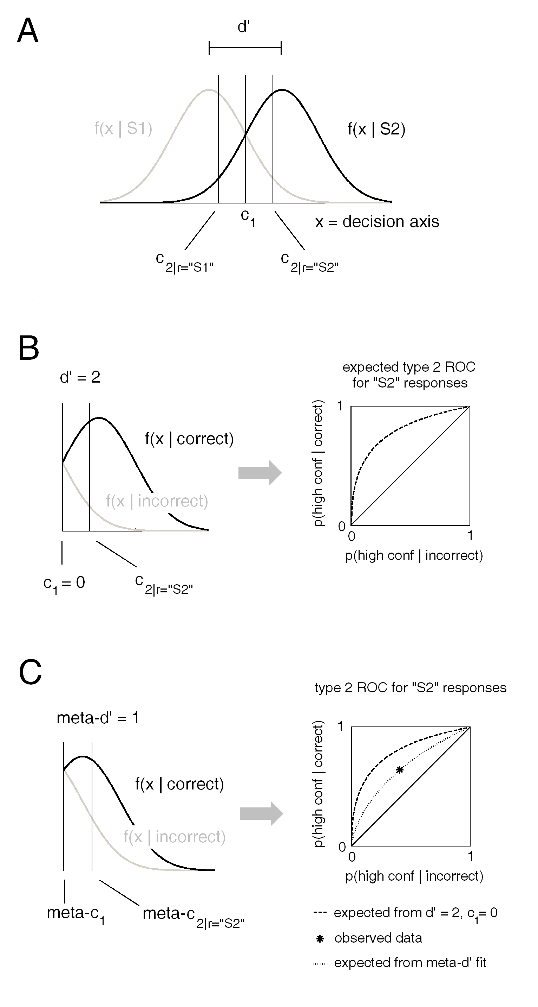
Figure 1. Signal detection theory analysis of type 2 (metacognitive) performance. Following the work of Galvin et al. (2003), we describe the theoretical relationship between type 1 and type 2 SDT models. This relationship can essentially be run in reverse in order to characterize observed type 2 data in terms of the type 1 parameter values (for d’ and c) that would have been expected (according to standard SDT) to have generated them. We give the name meta-d’ to the value of d’ that would have made the observed level of type 2 performance expected according to SDT. Meta-d’ allows us to characterize type 2 performance in terms of the type 1 parameter d’. Meta-d’ and d’ can be directly compared to arrive at a relative measure of type 2 sensitivity that corrects for the influence of type 1 task performance. (A) The standard signal detection model. The observer must discriminate between stimulus classes S1 and S2. Each stimulus presentation generates a value on an internal decision axis corresponding to the evidence in favor of S1 or S2. Evidence generated by each stimulus class is normally distributed across the decision axis, and the distance between these distributions (d’) in standard deviation units measures how well the observer can discriminate S1 from S2. The observer sets a decision criterion c₁, such that all signals exceeding c₁ are labeled "S2" and all those failing to exceed c₁ are labeled "S1." The observer also sets criteria c_{2|r="S1"} and c_{2|r="S2"} to determine confidence ratings (higher confidence ratings are given for signals farther from c₁). In this example, we set d’ = 2 and c₁ = 0. (B) Expected type 2 sensitivity from d' and c₁. Consider only trials where the observer responds "S2," i.e. only the portion of the decision axis exceeding c₁. Then the S2 distribution corresponds to the distribution of evidence for correct responses (i.e. S2 stimuli classified as "S2"), and the S1 distribution corresponds to the distribution of evidence for incorrect responses (i.e. S1 stimuli classified as "S2"). All trials surpassing c_{2|r="S2"} are endorsed with high confidence. Sweeping the c_{2|r="S2"} criterion across the decision axis generates different values for type 2 false alarm rate (p( high confidence | incorrect )) and type 2 hit rate (p( high confidence | correct )), and thus generates a type 2 ROC curve. (Similar considerations hold for "S1" responses.) Thus, it follows from the standard signal detection model that d' and c₁ are jointly sufficient to determine type 2 sensitivity for each response type. (C) Characterizing type 2 sensitivity. Consider only trials where the observer responds "S2," i.e. only the portion of the decision axis exceeding c₁. The analysis from (A) and (B) can be inverted in order to characterize type 2 sensitivity in terms of type 1 parameters. Suppose that the observer has d' = 2 and c₁ = 0, with "S2" responses having a type 2 hit rate = .64 and a type 2 false alarm rate = .41. We may characterize type 2 sensitivity as meta-d', i.e. the level of d' that would have been expected to have generated the observed type 2 data pair. In this example, meta-d' = 1 even though d' = 2, indicating type 2 sensitivity below expectation. Though not pictured here, this analysis can likewise be applied to "S1" responses.

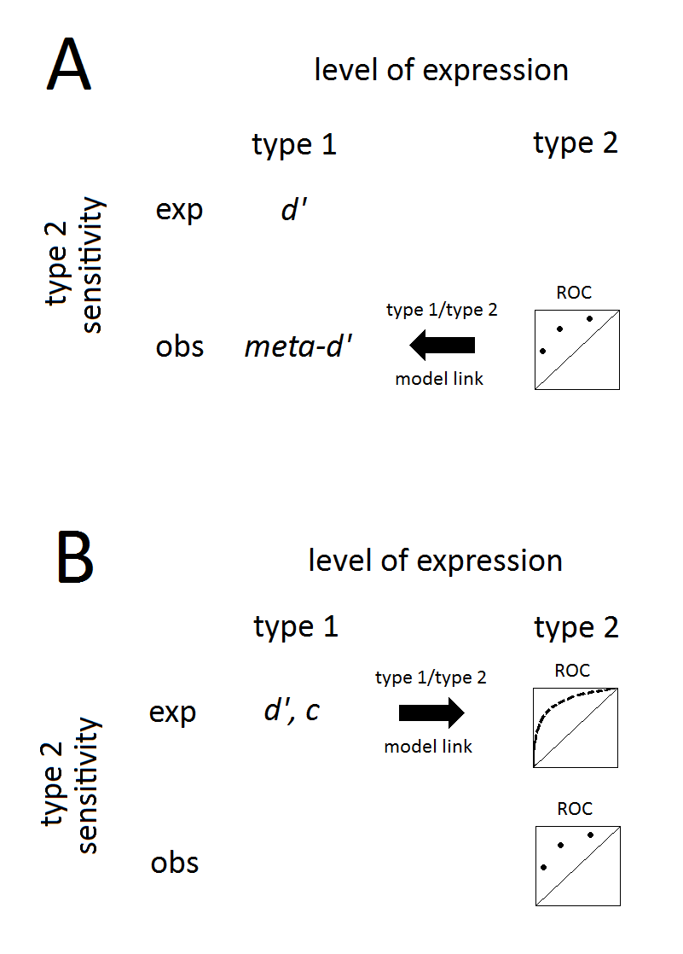
Figure 2. Schematic representation of two ways to quantify absolute and relative type 2 sensitivity in an SDT framework. Absolute type 2 sensitivity is a quantification of the observed type 2 performance, derived from the type 2 ROC. Absolute type 2 sensitivity can be expressed at either the level of type 1 or type 2 processes due to the theoretical relationship between type 1 and type 2 processes in SDT (Fig 1). Relative type 2 sensitivity is derived by a quantitative comparison between observed and expected (according to SDT) values of absolute type 2 sensitivity occurring on the same level of expression. (A) From type 2 to type 1. The observed type 2 ROC can be expressed in terms of the type 1 SDT parameter meta-d’ that would make the observed type 2 data expected. meta-d’, an absolute measure of type 2 sensitivity, can be compared to d’ to yield a relative measure. (B) From type 1 to type 2. An estimate of the area under the observed type 2 ROC can serve as an absolute measure of type 2 sensitivity. The observed values of type 1 parameters d’ and c can be used to generate an expectation for the type 2 ROC. The areas underneath the observed and expected curves can be compared to yield a relative measure of type 2 sensitivity.

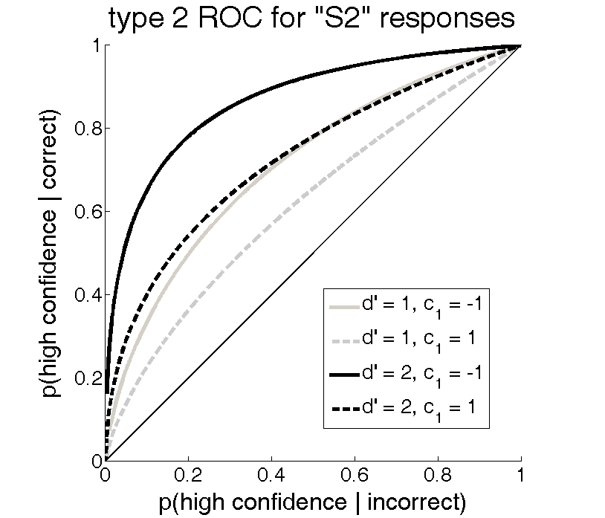
Figure 3. The theoretical effect of type 1 performance on type 2 sensitivity in the standard signal detection model. Type 2 ROC curves for trials where the observer classifies the stimulus as "S2" are influenced by sensitivity (d') and response bias (c₁) in the type 1 stimulus classification task (see Fig 1B). Because area under the ROC curve is an index of sensitivity, this implies that type 2 sensitivity is influenced by type 1 task performance. For instance, in the example here, confidence judgments discriminate between correct and incorrect "S2" classifications best when d' = 2 and c₁ = -1. Despite the variation in type 2 sensitivity, all curves represent the optimal level of type 2 sensitivity given the level of type 1 performance, according to the standard signal detection model. Thus, these differences in type 2 sensitivity are attributable only to variation in type 1 performance, not type 2 performance or "metacognition" per se. Though not pictured here, the ROC for overall (rather than response-conditional) type 2 performance is also sensitive to changes in d' and c₁ (Galvin et al., 2003).
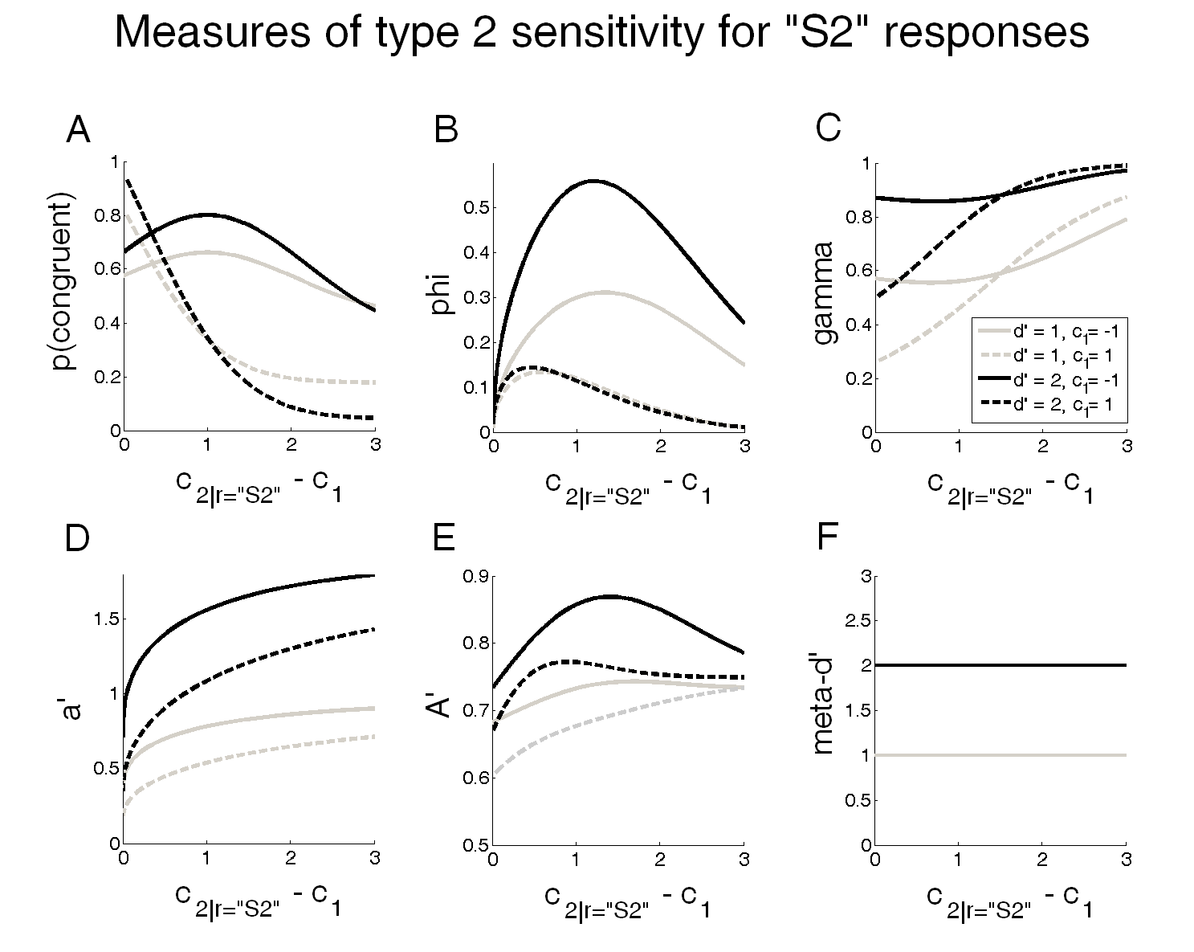
Figure 4. Theoretical variation in measures of absolute type 2 sensitivity for "S2" stimulus classifications, as a function of type 1 performance and type 2 response bias (d', c₁, and c_{2|r="S2"} ; (see fig 1B)). Horizontal axis for each figure represents the distance of c_{2|r="S2"} from c₁, i.e. the degree of conservative type 2 response bias. All measures reported here are computed from the type 2 FAR and type 2 HR produced by each conjunction of values for d’, c₁, and c_{2|r=”S2”} and thus are measures of type 2 sensitivity. Note that all measures but meta-d' are sensitive to type 1 and type 2 response bias. meta-d' is sensitive to differences in d', but this can be accounted for by a direct numerical comparison between meta-d' and d'. (A) p(congruent), i.e. the probability that confidence (high or low) is congruent with accuracy (correct or incorrect). (B) phi, a measure of correlation between accuracy and confidence. (C) gamma, a measure of correlation between accuracy and confidence. (D) a', the signal detection measure of type 2 sensitivity developed by Kunimoto et al. (2001). (E) A', an estimate of the area under the type 2 ROC curve based on a single (type 2 FAR, type 2 HR) pair. (F) meta-d', our signal detection measure of type 2 sensitivity.

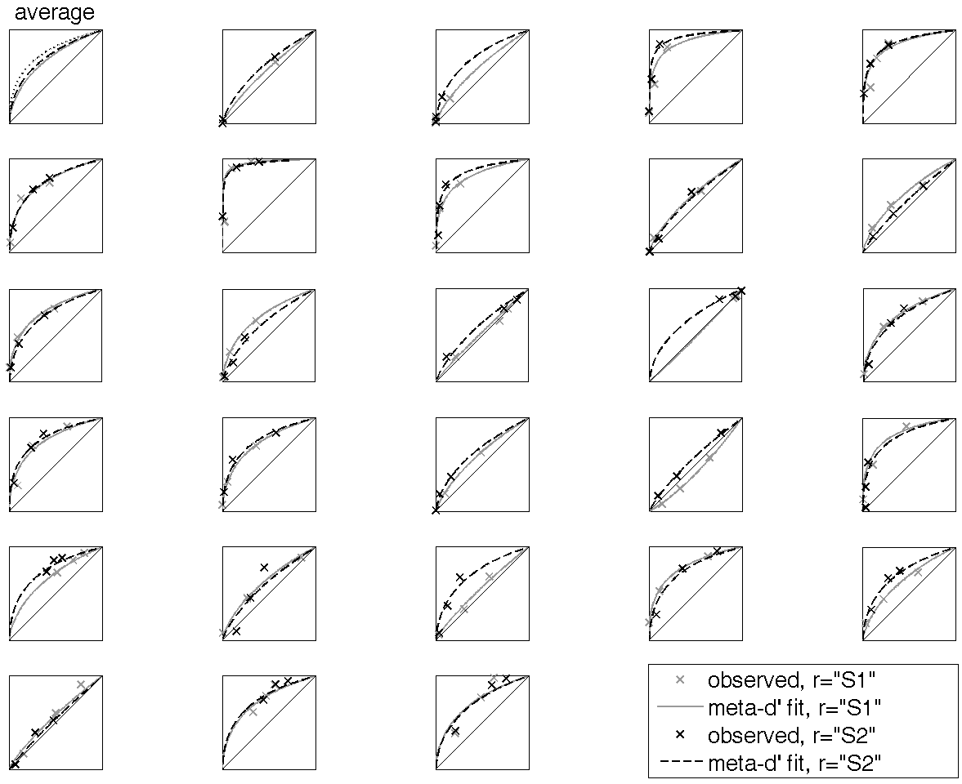
Figure 5. Response-conditional type 2 ROC data fits using the type 1/type 2 model link. Results of the meta-d’ estimation procedure from Study 1. Each plot corresponds to single subject data; the upper left plot displays between-subject averages. Continuous estimates of response-conditional type 2 ROC curves were generated for each subject by using the estimated values of meta-d’ in conjunction with the value of c’ estimated from the type 1 data (Fig 1; main text). The fitting procedure produced a close match to observed response-conditional type 2 HR and type 2 FAR for most subjects. In the upper left ROC, we plot the average response-conditional type 2 ROC curves derived from SDT-derived type 1 expectation (dotted lines; see Fig 1B) and from the data fitting procedure (solid and dashed lines; see Fig 1C, Fig 2). There is less area underneath the fit curves than underneath the expected curves, indicating that average absolute type 2 sensitivity was lower than expectation (see Fig 6, 7).

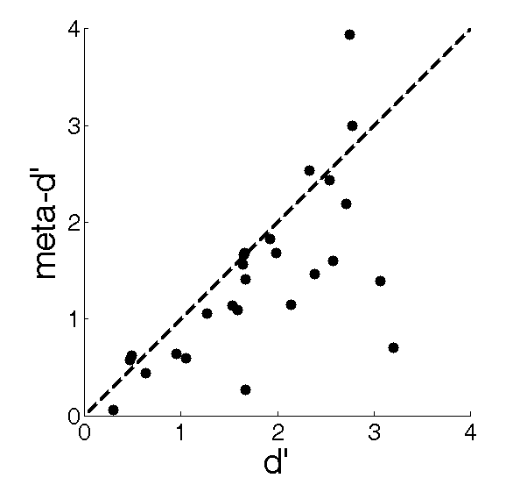
Figure 6. Observed vs. expected type 2 sensitivity in a spatial 2IFC task using meta-d’. 27 subjects performed a spatial 2IFC task and rated confidence in response accuracy (Study 1 from main text). Their absolute type 2 sensitivity was characterized using meta-d’ (Fig1; Fig 2A). Dots represent individual subject data and the dashed line shows the curve expected from SDT, meta-d’ = d’. There is a strong correlation between d’ and meta-d’ (r = .68, p = .0001), such that d’ serves as an approximate upper bound on meta-d’, in agreement with the theoretical link between type 1 and type 2 SDT models. Yet there is substantial between-subject variance in the relationship between meta-d’ and d’, such that several subjects fall well below the level of expected type 2 sensitivity and the group average for meta-d’ is significantly lower than d’ (paired t-test, p = .009). This suggests that we cannot take it for granted in empirical data that d’ = meta-d’, and thus meta-d’ has meaningful empirical work to do in contributing to absolute and relative measures of type 2 sensitivity.

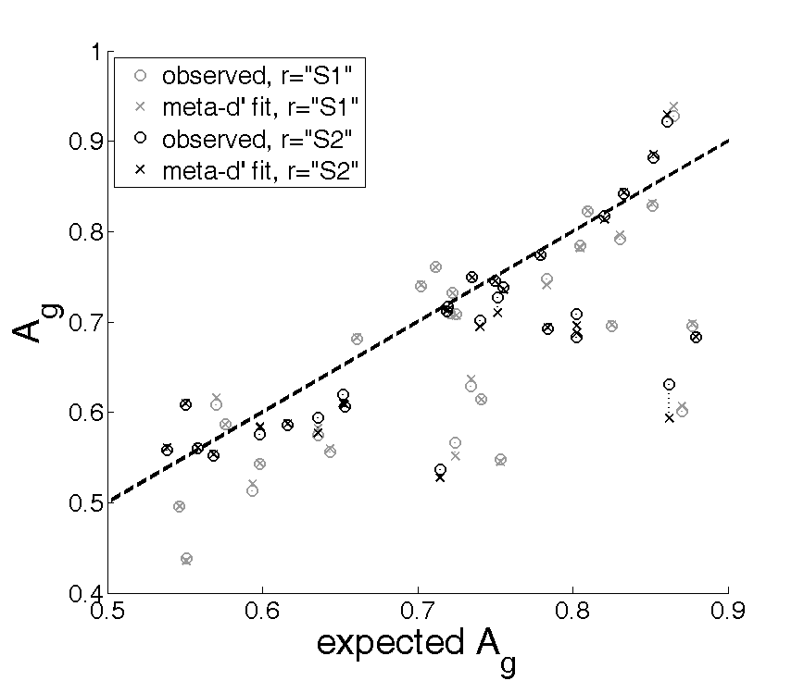
Figure 7. Observed vs. expected type 2 sensitivity in a spatial 2IFC task using A_{g}. We replicated the meta-d’ findings of Study 1 (Fig 6; main text) when characterizing absolute type 2 sensitivity with A_{g}, a non-parametric estimate of area under the type 2 ROC curve (Fig1; Fig 2B). This approach allows us to characterize observed type 2 sensitivity in a non-parametric way, although the fits to the data are parametric in the sense that they presume the theoretical link between type 1 and type 2 performance indicated in Fig 1. A correction was applied to expected and fit values of A_{g} in order to take into account its tendency to underestimate type 2 AUC (see main text for details). Circles and Xs represent observed and fit A_{g} for individual subjects and the dashed line shows the curve expected from SDT. The main features of Fig 6 are also present here: observed levels of absolute type 2 sensitivity correlate strongly with SDT expectation; SDT expectation sets an apparent upper bound on actual type 2 sensitivity; and there is substantial between-subject variation in the extent to which type 2 sensitivity deviates from expectation. All these observations point towards the integrity and usefulness of the theoretical and methodological approach endorsed here.

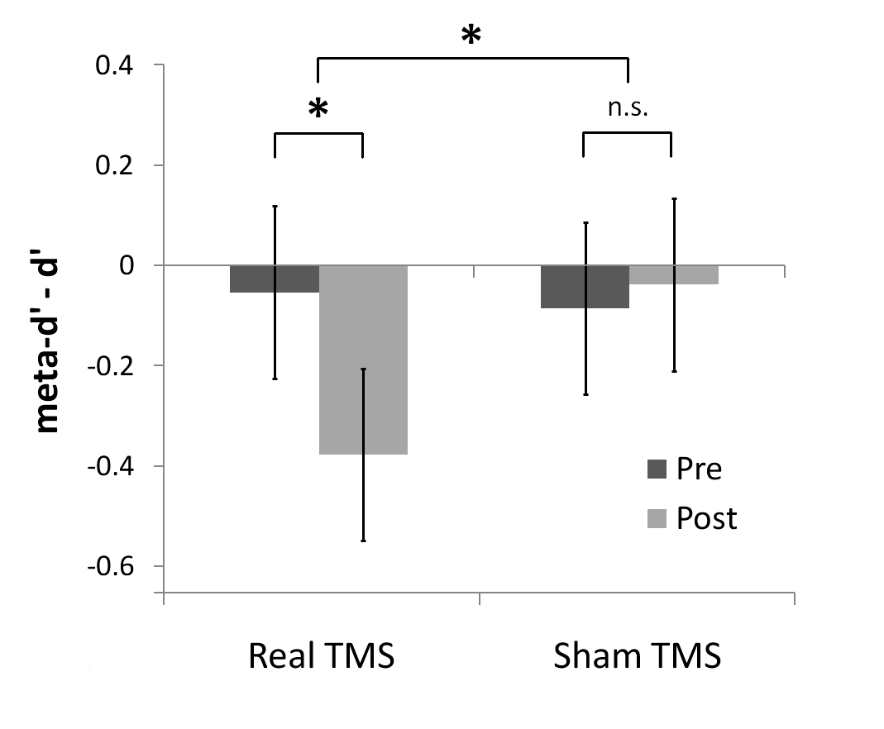
Figure 8. Selective manipulation of relative type 2 sensitivity using TMS. Rounis, Maniscalco, Rothwell, Passingham, and Lau (2010) applied theta-burst transcranial magnetic stimulation to subjects performing a visual discrimination task with visual clarity ratings. TMS selectively affected relative type 2 sensitivity (measured as meta-d' - d') without affecting type 1 performance or frequency of high clarity ratings. In baseline and control conditions, meta-d' did not significantly differ from d', suggesting type 2 sensitivity in line with the SDT expectation. Following administration of TMS to dorsolateral prefrontal cortex, meta-d' was significantly lower than d', indicating suboptimal type 2 sensitivity. * p < .05. Pre: before TMS. Post: after TMS. Sham TMS: a control condition where TMS was not actually applied.
Appendix
The effect of variation in type 2 sensitivity on the shape of the type 1 ROC curves constructed from rating data
It is popular practice to estimate multiple (type 1 FAR, type 1 HR) data points for a single observer by asking the observer to provide a stimulus classification and confidence rating on every trial. In a task with two available stimulus classification responses “S1” and “S2”, and C available levels of confidence rating, the observer has a total of N = 2*C possible responses to give on each trial. One can construct a type 1 ROC with N-1 ROC points by considering each way of partitioning the N response options into two response bins. We assume that each such partition represents a way the observer could have classified the presented stimuli as “S1” or “S2.”
For instance, in a task with two levels of confidence, we can calculate a type 1 ROC point from the observer’s probability of classifying S1 and S2 stimuli, respectively, as “S2”. We might proceed to imagine that had the observer been more conservative in classifying stimuli as “S2,” he only would have done so for high confidence “S2” responses. But since we have collected confidence data, we already know the observer’s tendency to classify the stimuli in this way, and so we can obtain another type 1 ROC point from the observer’s probability of classifying S1 and S2 stimuli as “S2” with high confidence. A third ROC point can be calculated by imagining that a very liberal usage of the “S2” response would entail that the observer would only respond “S1” if that response was endorsed with high confidence.
More formally, type 1 HR and FAR are stimulus classification probabilities contingent upon stimulus identity; that is,
type 1 HR = p(classification response="S2" | stimulus=S2)
type 1 FAR = p(classification response="S2" | stimulus=S1)
In the rating approach to constructing type 1 ROCs, we simulate extra type 1 ROC points by assessing the joint probabilities of stimulus classification and confidence rating contingent upon stimulus identity. For instance, consider a simple case where the observer must classify a stimulus as "S1" or "S2" and endorse that classification with high or low confidence. There are 4 possible response categories and thus 3 type 1 ROC points. In the following, let "r" denote "stimulus classification response", "conf" denote "confidence", and "stim" denote “stimulus.” Then the three type 1 ROC points that can be constructed from this data set are:
type 1 HR_{high conf ”S2”} = p(r="S2" & conf=high | stim=S2)
type 1 FAR_{high conf “S2”} = p(r="S2" & conf=high | stim=S1)
type 1 HR_{true} = p(r="S2" | stim=S2)
type 1 FAR_{true} = p(r="S2" | stim=S1)
type 1 HR_{high conf “S1”} = 1 - p(r="S1" & conf=high | stim=S2)
type 1 FAR_{high conf “S1”} = 1 - p(r="S1" & conf=high | stim=S1)
By the law of conditional probability, p(x & y) = p(x|y) * p(y). Applying the law of conditional probability to type 1 HR_{high conf “S2”} and type 1 FAR_{high conf “S2”} above, we obtain:
type 1 HR_{high conf ”S2”} = p(r="S2" & conf=high | stim=S2)
= p(conf=high | r="S2" & stim=S2) * p(r="S2" | stim=S2)
= p(conf=high | correct "S2" classification) * p(r="S2" | stim=S2)
= type 2 HR|r="S2" * type 1 HR_{true}
type 1 FAR _{high conf ”S2”} = p(r="S2" & conf=high | stim=S1)
= p(conf=high | r="S2" & stim=S1) * p(r="S2" | stim=S1)
= p(conf=high | incorrect "S2" classification) * p(r="S2" | stim=S1)
= type 2 FAR|r="S2" * type 1 FAR_{true}
By similar reasoning,
type 1 HR_{high conf “S1”} = 1 - [ type 2 FAR|r="S1" * (1 - type 1 HR_{true}) ]
type 1 FAR_{high conf “S1”} = 1 - [ type 2 HR|r="S1" * (1 - type 1 FAR_{true}) ]
The relevant point to notice is that there is a direct link between the type 1 ROC points constructed from rating data and type 2 sensitivity. The extra type 1 ROC points obtained from confidence ratings are multiplicative products of type 1 HR and FAR (or the complements of these, miss rate and correct rejection rate) and response-conditional type 2 HR and FAR.
In turn, this implies that the shape of the type 1 ROC constructed from rating data depends jointly on type 1 performance and type 2 sensitivity. For instance, suppose d' > 0 but meta-d' = 0, i.e. at each level of confidence responding, type 2 FAR = type 2 HR. Since every (type 2 FAR, type 2 HR) pair contains equal values, each point on the rating constructed ROC curve will be generated by multiplying FAR_{true} and HR_{true} by the same factor. It follows that the rating-constructed type 1 ROC curve will be a piecewise linear function consisting of two linear scalings of (FAR_{true}, HR_{true}) (Fig A1). When meta-d' = d', the shape of the type 1 ROC curve will be identical to the smooth, continuous shape predicted from standard signal detection theory (Fig A1). When meta-d' < d', the ROC curve will lie between these two extremes.
In fact, Clifford, Arabzadeh, & Harris (2008) argued that the shape of the rating-constructed type 1 ROC curve could be used to assess type 2 sensitivity. In particular, they argued that if rating-constructed type 1 ROC points are better fit by a piecewise linear ROC curve than the ROC curve predicted by SDT, then one can infer that metacognitive sensitivity is suboptimal. This approach has the virtue of assessing type 2 sensitivity independently from type 1 performance. In the type 1 ROC, sensitivity and response bias combine to define the location in ROC-space of the “true” type 1 ROC point (FAR_{true}, HR_{true}). Because the relative angularity or smoothness of the best fitting type 1 ROC curve is independent of the location of the “true” type 1 ROC point, this measure of type 2 sensitivity is effectively independent from type 1 task performance. Thus, this method has the unique distinction of assessing relative type 2 sensitivity, as opposed to the majority of previously proposed methods that in fact assess absolute type 2 sensitivity.
However, the approach of Clifford et al. (2008) is limited in several ways. Historically, it has been difficult to establish empirical deviations from SDT expectation in rating-constructed type 1 ROC shape (Macmillan & Creelman, 2005). One reason for this difficulty may be that the area under the rating-constructed type 1 ROC curve does not change drastically even for extreme differences in type 2 sensitivity. This is because, as entailed by the above discussion, the area under the rating-constructed type 1 ROC curve is predominately determined by the "true" type 1 ROC point, with only marginal contributions from variation in type 2 sensitivity. For instance, when d' = 2 and c₁ = 0, the area under the rating-constructed type 1 ROC is .921 if meta-d' = d' = 2 and .841 if meta-d' = 0. Thus in this example, a 100% difference in type 2 sensitivity generates only an 8.7% difference in area under the type 1 ROC curve. Recent studies such as Mueller and Weidemann (2008) have used the approach of assessing the shape of the rating-constructed type 1 ROC curve to make inferences about type 2 sensitivity, but these approaches seem to require manipulating the type 1 criterion in extreme ways via strong base rate or response incentive manipulations in order to detect a difference between conditions in type 1 ROC shape. This is because increasing the bias of the type 1 criterion tends to increase the influence of type 2 sensitivity on the area under the rating-constructed type 1 ROC curve.
Another weakness of this approach is that it makes graded assessment of type 2 sensitivity difficult. The approach Clifford et al. (2008) endorse essentially amounts to a hypothesis test of the null hypothesis that meta-d' = d'. By contrast, the approach we propose in this paper allows one to assess type 2 sensitivity on a graded scale and make graded comparisons to expectation. For instance, if M_{ratio} = meta-d' / d' = .5, then the observer exhibits type 2 sensitivity that is only half as good as we would expect it to be, judging by type 1 performance. Likewise, our approach can detect cases where type 2 sensitivity outperforms SDT expectation, whereas the approach of Clifford et al. is only applicable to cases type 2 sensitivity matches or underperforms SDT expecation.
We demonstrate these points empirically by considering data from Study 1 cited in the main text. In that study, we found that meta-d’ was significantly lower than d’. On average, observers’ meta-d’ underperformed the expected value of d’ by 23%. This below-expectation level of type 2 performance may also be seen in a slight deformation of the rating-constructed type 1 ROC (Fig A2). However, this effect is scarcely noticeable in the areas under the type 1 ROC curves—a lower bound on the estimate of the observed type 1 AUC for the between-subject means of type 1 FAR and type 1 HR (calculated as A_{g}; Pollack & Hsieh, 1969) underperforms the area under the SDT-expected type 1 AUC by only 1.3%. Thus, in this example, the percent deviation from expectation for these two methods of assessing relative type 2 sensitivity differs by a factor of about 17.

References
Clifford, C. W. G., Arabzadeh, E., & Harris, J. A. (2008). Getting technical about awareness. Trends in Cognitive Sciences, 12(2), 54-58.
Macmillan, N. A., & Creelman, C. D. (2005). Detection Theory: A User's Guide (2nd ed.). Lawrence Erlbaum.
Pollack, I., & Hsieh, R. (1969). Sampling variability of the area under the ROC-curve and of d'e. Psychological Bulletin, 71(3), 161-173.

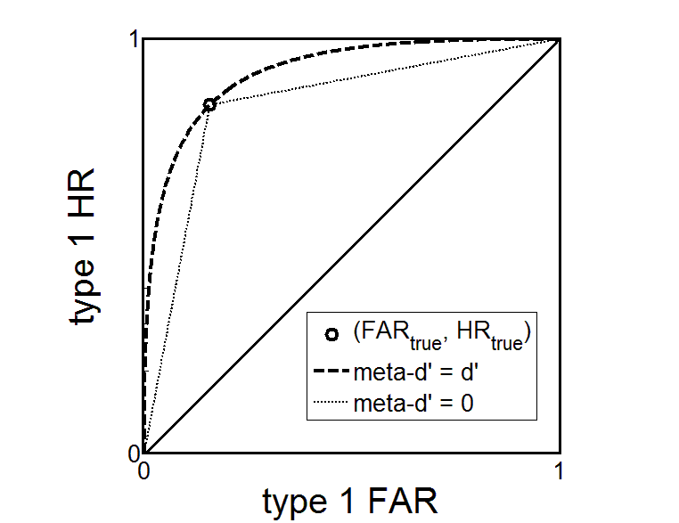
Fig A1. Theoretical demonstration of the influence of type 2 sensitivity on type 1 ROC constructed from confidence ratings. Because type 1 ROC points generated from confidence rating data depend on type 2 sensitivity, variation in type 2 sensitivity affects the shape of the type 1 ROC curve. In this graph we consider the shape of the type 1 ROC when type 1 performance is d’ = 2, c₁ = 0. When meta-d’ = d’, type 2 sensitivity meets the SDT expectation and thus the rating constructed type 1 ROC curve also matches the SDT expectation. When type 2 sensitivity is at chance (i.e. meta-d’ = 0), the shape of the type 1 ROC curve becomes piecewise linear and the area underneath the curve decreases. Values for meta-d’ between 0 and d’ generate ROC curves inbetween the two shown here.
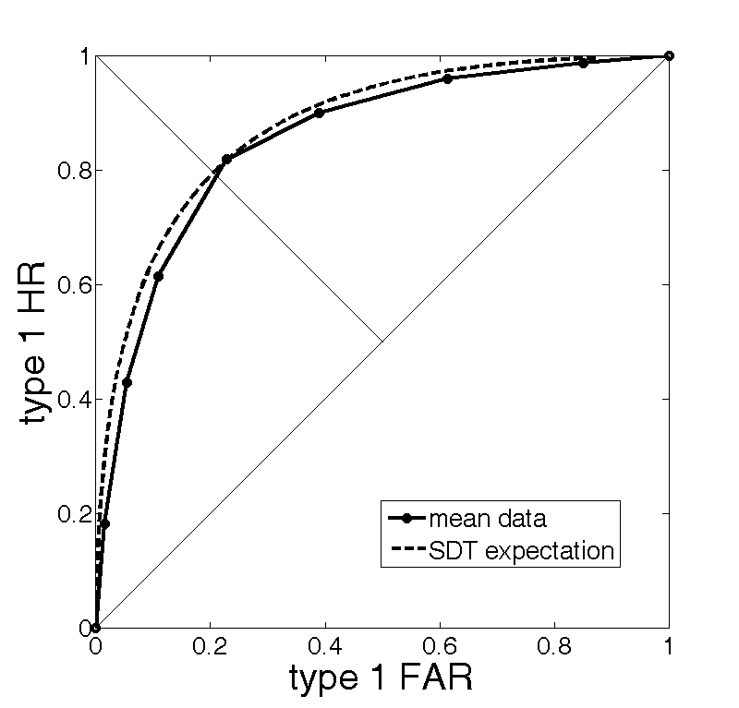
Fig A2. Empirical demonstration of the influence of type 2 sensitivity on type 1 ROC constructed from confidence ratings. Average type 1 FAR and type 1 HR from Study 1 reported in the main text. In this data set, meta-d’ is significantly lower than d’. This effect manifests as a slight deviation of the rating-constructed type 1 ROC from SDT expectation. In this example, the percent deviation from expectation in the area under the type 1 ROC is smaller than the percent deviation from expectation in meta-d’ by a factor of about 17.

